International Hellenic University

MSc in e-Business and Digital Marketing
Course: Digital Marketing
26/01/24

Athanailidou Eleni, Stefania Dimitrakopoulou, Maria Kardakou, Evangelia Papantidou
HEBE e-shop (cosmetic): https://dmlabs.ihu.edu.gr/group2/

Introduction:
The beauty industry plays a pivotal role in the global market, catering to people of all backgrounds and cultures.
Nowadays, with the rise of beauty e-shops, there's a big change in the market. These are online shops dedicated to selling beauty products. They've become important players, adapting to the preferences of tech-savvy consumers, and gaining their trust. These shops connect consumers with a wide range of beauty products, from well-known brands to exceptional finds from smaller producers. Online platforms also allow these e-shops to use cool technologies and engaging content to capture the audience's interest.
Our digital marketing team is currently deeply engaged in collaboration with a highly regarded client, a digital commerce agency specializing in the dynamic cosmetics sector. This agency serves as a heart for various brands and providers, curating an extensive collection of beauty products exclusively available on their e-shop, housed on their website.
As entrusted by our client, our team's main mission revolves around a dual objective: to enhance brand visibility and foster increased conversions and sales through their online platform.
In the e-shop "HEBE" you will find cosmetic companies (brands) and products that are addressed to each customer personally. Delulu, SEME, KriMa, Rouf, and Fedon are some of the brands that were carefully selected to staff "HEBE".
The whole concept is based on the goddess Hebe, the goddess of eternal youth, prime of life, and forgiveness, that notion inspires the vision. Pure and ethereal, like the goddess, are the beauty products any beauty lover can discover on the site. The products' constant upgrading and quality controls make it one of the most authoritative sites for your online cosmetics purchase.
- Delulu: provides the perfect foundation, concealer, etc. for easy application and a lasting, luminous glow.
- SEME: is a company that excels in " featherweight " cosmetics, for daily use and for all ages.
- KriMa: is a brand aimed at ethical and cruelty-free cosmetics. 99% natural ingredients with vegan origin, creating the perfect cosmetic choice for the right facial friction.
- Rouf: Manufactures cosmetics based on MoistureGri technology, which provides deep hydration to the skin for a remarkable 12 hours without any sensation, offering a radiant finish.
- Fedon: Discover Fedon's brand-new collection of cosmetics specially designed for mature skin, where beauty meets unconventional elegance. Embrace your unique journey with formulations that prioritize hydration and anti-aging.
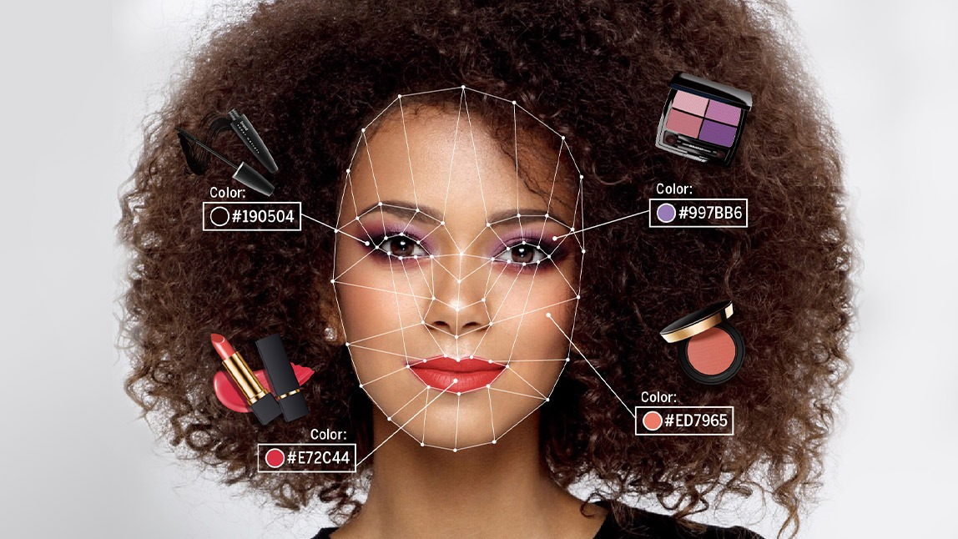
Apart from special and unique cosmetics, on the site, you will find a blog with useful makeup tips. Also, there is a separate list with all the offers that you can find in the e-shop and a unique “Beauty Assistant '' which covers all the 7 billion faces on this planet with AI help. More specifically, we are not just interested in increasing revenue, but in creating costumers for life, so this is why we offered them a free service that provides them with insights into which products (shades, textures etc.) from our site best highlights their best features.

Part A & B

Keyword Research and Competitor Analysis

- Keyword Analysis
We conducted extensive keyword research to first understand what potential customers are looking for and interested in. It is fundamental we find the appropriate keywords that will function as a lynchpin between the users search journey and our website. A series of keyword tools were incorporated to identify these keywords: Semrush, Ubersuggest, Google Trends. More specifically, Google Trends helped us understand the consumers' behavior during seasonal times so we can adjust our offer section accordingly. As for the other artifacts, we select the ones that align with our personas. For example, we target mature women, so it was important to see if women of that category were looking for makeup products that facilitate their special requirements and they did. So, keywords like foundation for mature skin, hydrating foundation, ingredients that are known for their beneficial features on mature complexions like hyaluronic acid, vitamins, and of course SPF. Another promising segment in the market is vegans, so we highlight using keywords such as vegan-friendly foundation lipstick, or just vegan products, organic, cruelty-free, or all-natural. Another point worth mentioning is the branded searches users do. In our competitors' analysis, we observed that consumers directly search for specific brands like Mac or retailers like Sephora and Notino instead of product categories. On top of that, our launched brands are fictional, meaning that we have to deal with the challenge of users' prior unfamiliarity with the products. To resolve the aforementioned issue, we created a blog that answers queries related to beauty products to further boost keyword strategy.

- Competitor Analysis
To begin with our competitors, in the Greek market right now the biggest players are Sephora, Hondos Center, Notino, LookFantastic, and Galerie de Beaute. Sephora justifiable is our most challenging competitor. Sephora has managed to rank high to most of our Keywords, showcasing its strong SEO capabilities. A good enough effort is made on behalf of Lookfantastic regarding keywords like vegan foundation or hydrating foundation. But what is fascinating concerning our competitors and their keywords is the fact that the more specific a beauty keyword/phrase might be like a foundation for mature skin the less possible it was to be incorporated in their SEO strategy. We found mainly articles from third-party websites that recommend some brands. This observation provided us with some insights into the disposable keyword capabilities.

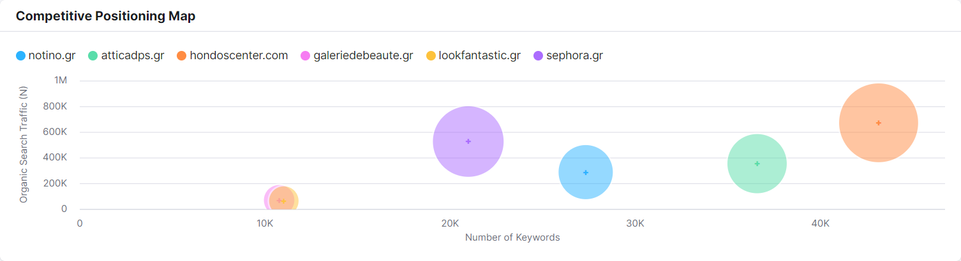

SEO Development
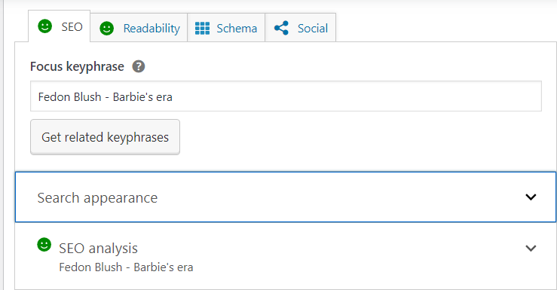
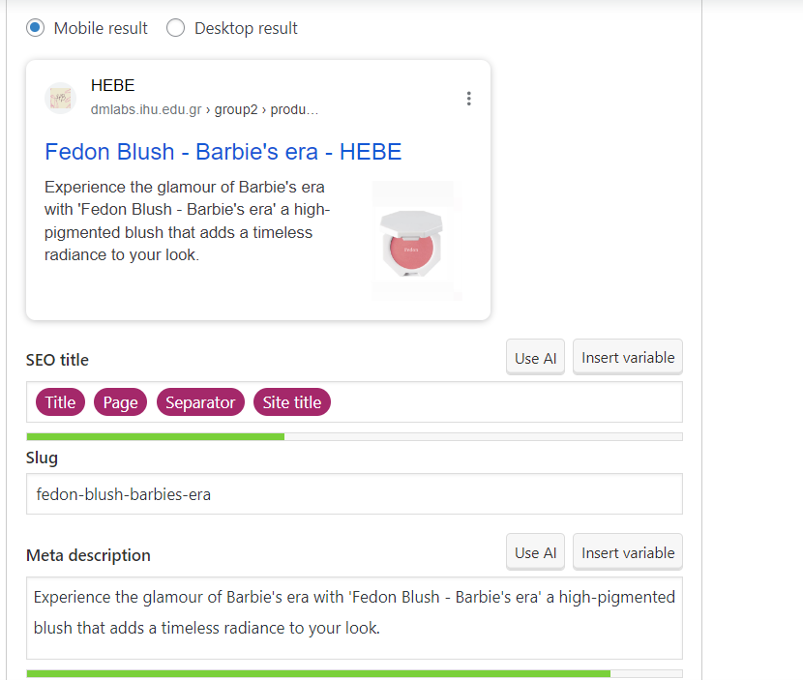
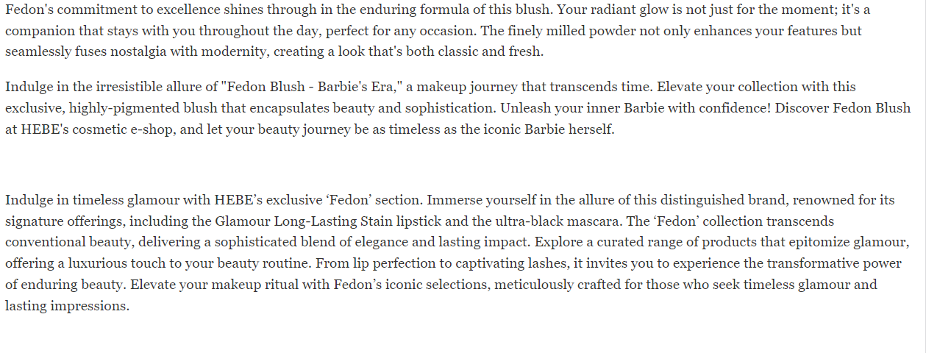
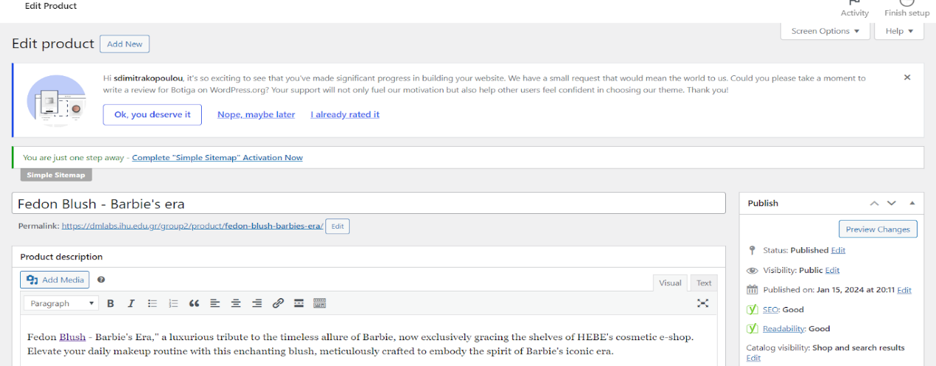
Fedon Blush- Barbie’s era

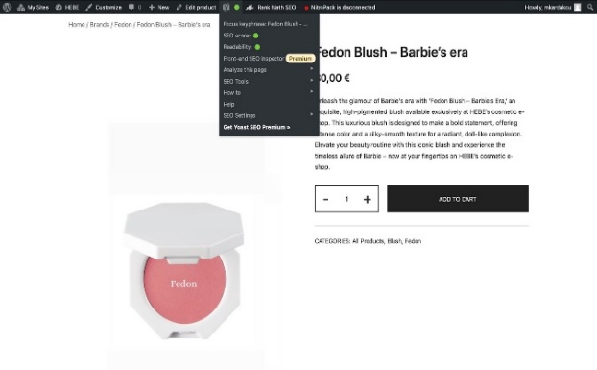

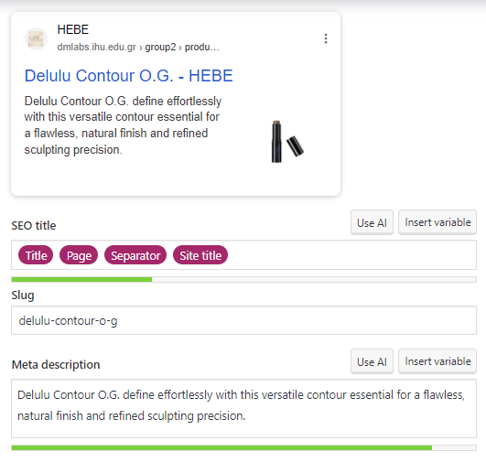
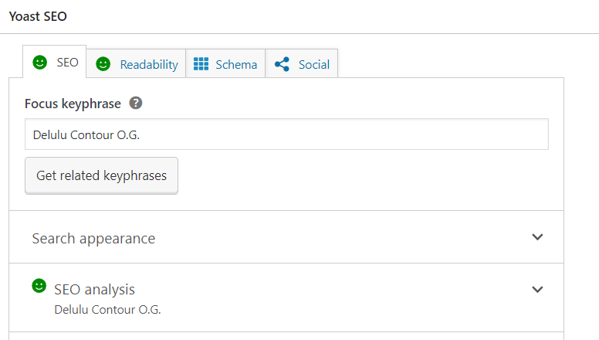
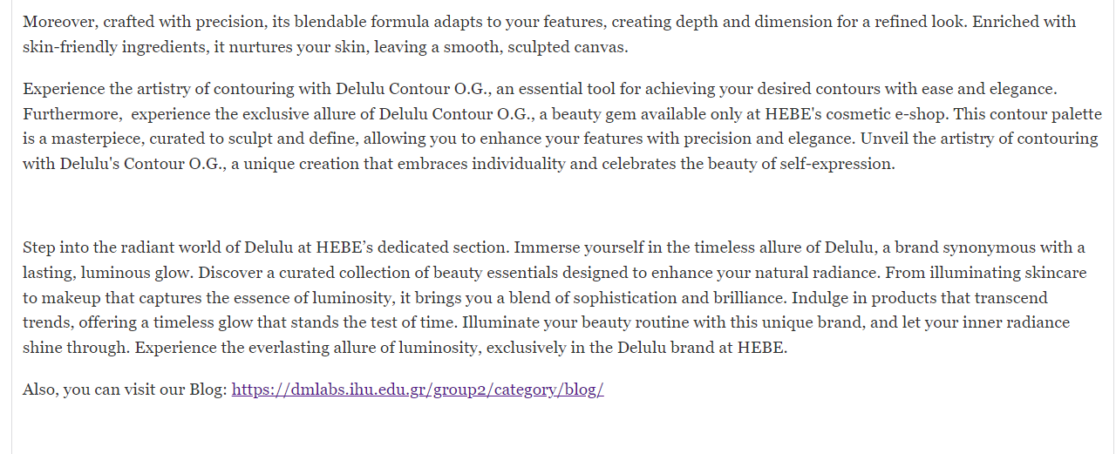
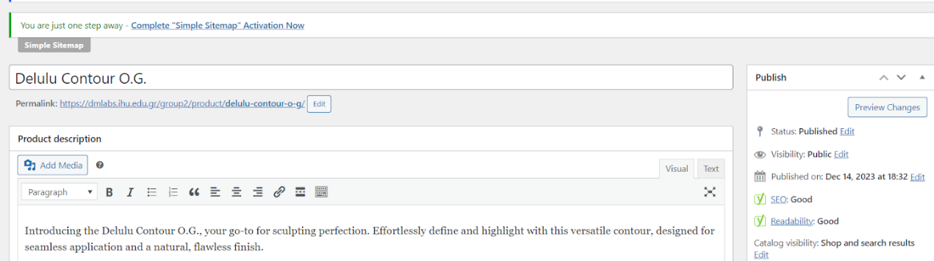
Delulu Contour O.G.

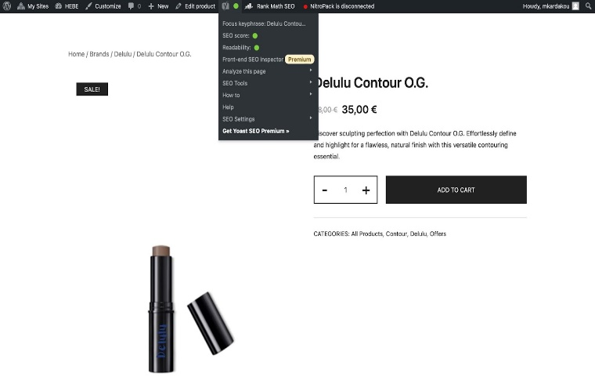

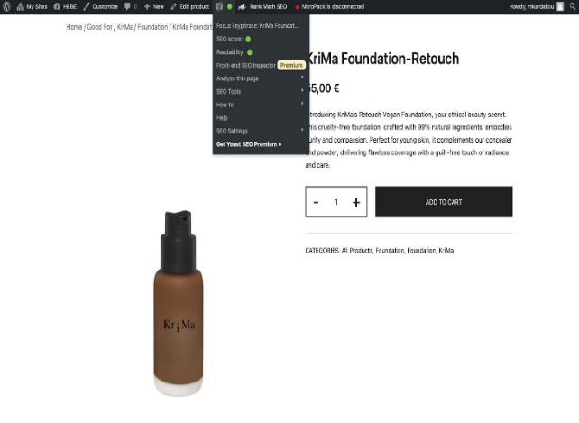
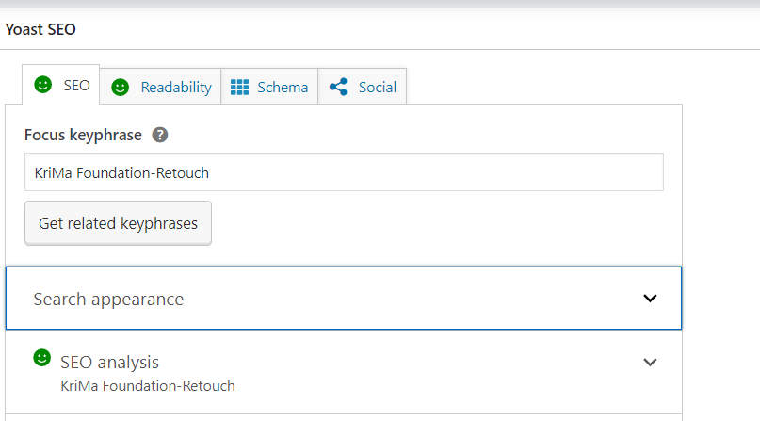
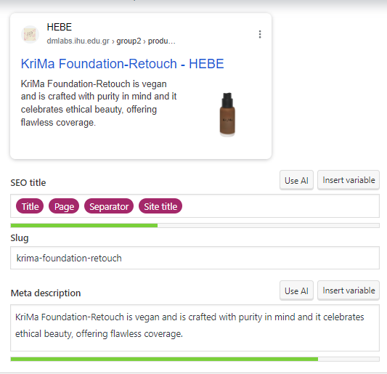
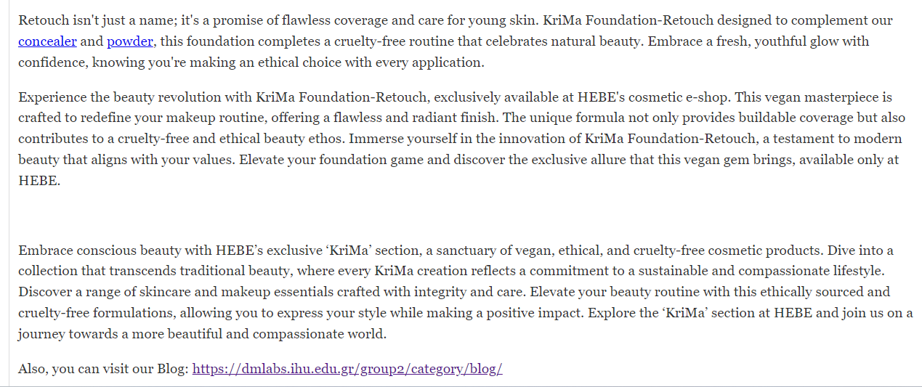
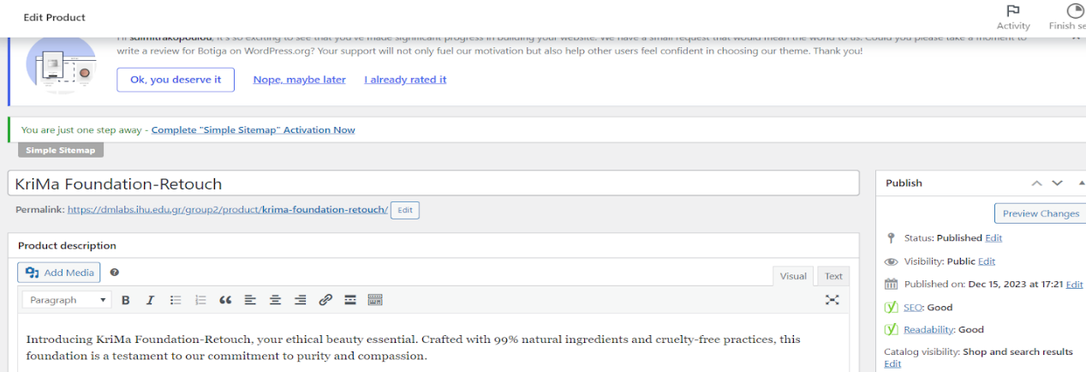
KriMa Foundation- Retouch

We managed to test the SEO scores of our content for 3 of our products (Fedon Blush- Barbie's era, Delulu Contour O.G., KriMa Foundation- Retouch). We chose the appropriate focus keyphrases, SEO titles, slugs, and Meta descriptions to create products with very good SEO scores. Also, we chose to add internal links to the texts and properly edited photos for the biggest increase in SEO scores.

Last but not least, since we are a brand-new site it make sense not to rank on the first positions of SERP despite all our SEO efforts. To resolve that we created a Blog with useful tips and generally beauty related topics that might answer to user’s search queries and potentially rank higher by this technic.

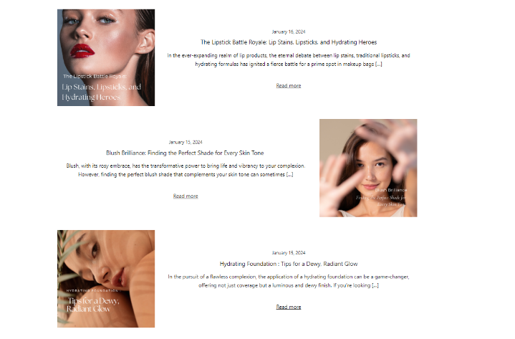

Part C

We decided to promote on this period of time our vegan brand KriMa and more specifically KriMas brand new Foundation- Retouch and Powder- Zeroshine. We chose only these two since we want them to be our top sellers of the brand.
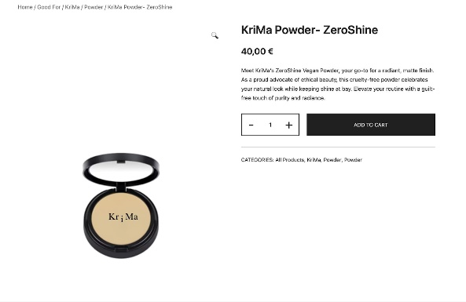
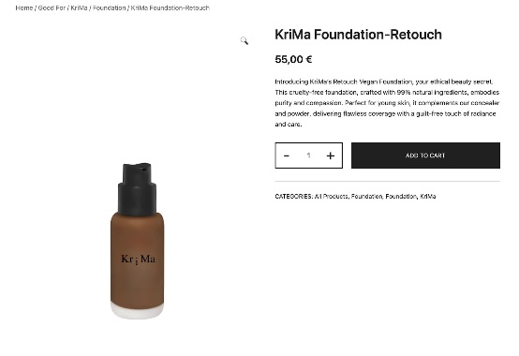

Vegan customers are a promising segment in the market, so we highlight using keywords such as vegan-friendly foundation and powder, or just vegan products, organic, cruelty-free, or all-natural.

We separated our keywords into two big groups, the one is the branded ad group and the second is the product-related ad group. On the first one, we incorporated keywords like Krima Foundation and Krima Powder, and in the second one: vegan-friendly foundation and powder, cruelty-free, all-natural foundation and powder, organic, no parabens, 100% pure.
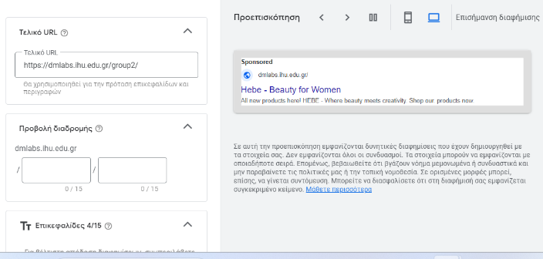
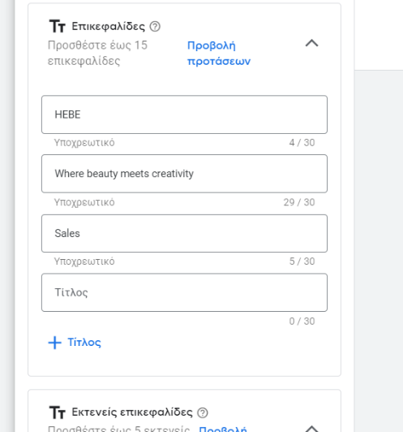

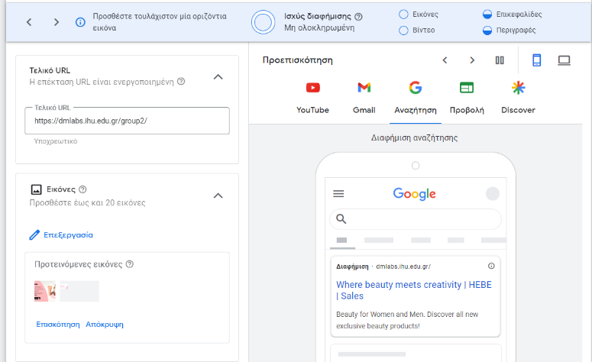

Our Performance Max campaign aims to drive sales by strategically organizing ad groups by targeting a specific group of audience (mature women). We use branding keyword ad group “Krima Foundation” and in addition, we capture a specific product keyword ad group for the “Krima Foundation”. Last but not least, some of the generic keyword groups that we used are “Discover all-new exclusive beauty products”, “Beauty for women and men”, and “All new products here”. As a long heading, we use the name of our website “HEBE”, where beauty meets creativity.

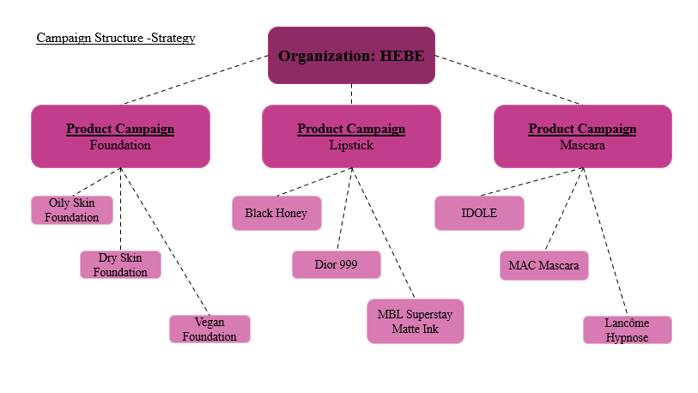

Our Campaign Structure-Strategy is based on this diagram. We initiated our approach by selecting three different products (Foundation, Lipstick, and Mascara) and conducted research on keywords related to them. Notably, our findings revealed that the keywords primarily centered around brand names (branding keywords). This discovery led us to the conclusion that to boost our Network Campaign in Google Ads, we should align our strategy with that of our competitors. Consequently, our emphasis should be on elevating brand awareness.

PPC STRATEGY PLAN
Scope of our PPC Strategy:
Our main aim through this Google Ad is to effectively promote our newly launched product of the KriMa brand, KriMa Foundation. We want to make the customers aware of this new release and boost its sales.

Search Campaign:
As a keyword for this ad, we used Krima foundation. Regarding the elements of our ad copies stand the following. 1) All new products here! Scope: This declaration informs our customers about our new releases and the place where they can find them (our website) 2) Discover all new exclusive beauty products! Scope: This header functions as our call-in action line to encourage users visit our site. 3) Beauty for Women and Men Scope: This last header not only defines our target audience to the search engine but also informs our audience addressed to them.
Performance Max Campaign:
- Target Audience: Emphasis given on mature females.
- Responsive Display Ads:
We chose to run our Google Ad on the Google’s Network, that entails a great deal of options such as websites, applications, and platforms.
- Text Ads:
- Google Search Results: This type of advertising is used and ranked above the organic results on the SERP. The distinctive element that differentiate it from the organic results is the Ad indicator. Users view Text ads, when their searches align with the Text Ad keywords

- Google Search Partners: Textual advertisements can also be displayed on beauty websites within Google's Search Network. It has created partnerships with websites that house Google Ads.

- Elements of a Text Ad:

  - Headers: a) All new products here! b) Discover all new exclusive beauty products! and c) Beauty for Women and Men.
  - Descriptions: Where beauty meets creativity. On this statement we aim to create a perception to our customers about our identity, that we are a website that cherishes creativity and beauty.
  - URL Paths: We have embedded a URL to drive traffic into advertised product page ( Krima Foundation).

- Image Ads:
This type of advertisements is presented on a series of platforms such as sites, applications and GDN.

Responsiveness of the Displayed Ads
We reassured that our advertisement has an adjusting structure in order to reshape based on the user’s device (desktop, mobile or tablet). In every display, the core elements of the ad remain the same. By doing that, a greater audience reach is guaranteed.

Landing Page Enhancement
- Resonates with the advertising messaging: We used in our ad keywords into our landing page, like KriMa Foundation, because it's cruelty-free and also vegan, and for the aspect of the customers it's crucial to display on the landing page.
- Full information: KriMa Foundation it's a cruelty-free and vegan product, so we emphasize it especially to the vegan customers. We focused on the natural ingredients of the products, and not on the packaging. Realistically, high-quality images can improve all this customer experience in our e-shop, with this new brand.
- Website Optimization: Our goal for a good presentation of our e-shop is to have headers, like “Shop Now for Cruelty-Free Beauty!” to attract more customers. We want to make the customers' mobile journey interesting and effective, so we created responsive banners and pictures for all devices. We run a lot of tests for our website speed, responsiveness, etc. With a click-through rate method, we wanted to make the users' journey as simple as possible to feel like they are in the right place for the landing page.

Supervising and Optimizing
- Engagement on Performance Data: As of our scope we search the competitors' keywords to analyze the best one for "HEBE". We chose the most usable branded keywords to improve relevance and engagement.
- Funding Placement: Regarding our Performance Max, we set our haul budget at 500€. With every click-through rate, we placed a budget of 0,10€/click, and with this step, we wanted to see how many clicks we could have per customer, especially the weekly views.
- A/B Testing: We implement A/B Testing to see what target group of our customers' daily journey to understand this path better. We stand to real-time data and market trends to move along with all of our steps for our PPC strategy, always based on customer behavior, industry trends, and the competitive scenery.

