

SCHOOL OF SCIENCE AND TECHNOLOGY

MSc in e-Business and Digital Marketing

Course: Digital Marketing

Team members: Georgoulias Charalampos, Pardali Polyxeni, Tzavara Maria, Vasileiou Aikaterini

Part A & B
- Business Description:
For the purposes of the coursework in Digital Marketing, we decided to create a jewellery website that we would launch in Greece. Our business was named Eclat, a French word that means “shine”, as it reflects the elegance and the aesthetic we wanted our business to exude.
Eclat is a dynamic e-commerce platform that offers a curated selection of jewellery, targeting both women and men. Our mission is to provide a seamless and enjoyable shopping experience for jewellery lovers who are looking to elevate their style and can choose from a wide range of renowned jewellery brands.
As the jewellery world varies greatly in terms of price and material, we decided to include products with prices ranging between 50-250€ and materials like silver, steel, cubic zirconias and crystals, products accessible to the average consumer.
In order to ensure unparalleled quality and style, we included esteemed and trusted jewellery brands such as Pandora, Swarovski, Michael Kors, Jcou and Oxette. To make sure that their appeal is still holding strong, we used the platform Google Trends to note if there was any significant change in the demand of the aforementioned brands, confirming that the majority of the demand was, indeed, either steady or slightly elevated, as Figures 1, 2,3 and 4 show :
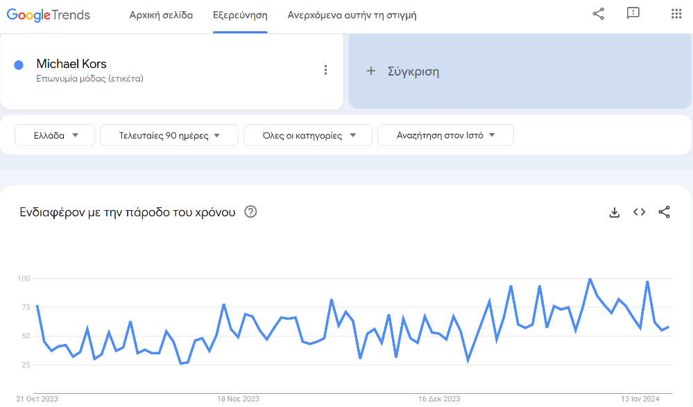
Figure 1. Google Trends- Michael kors
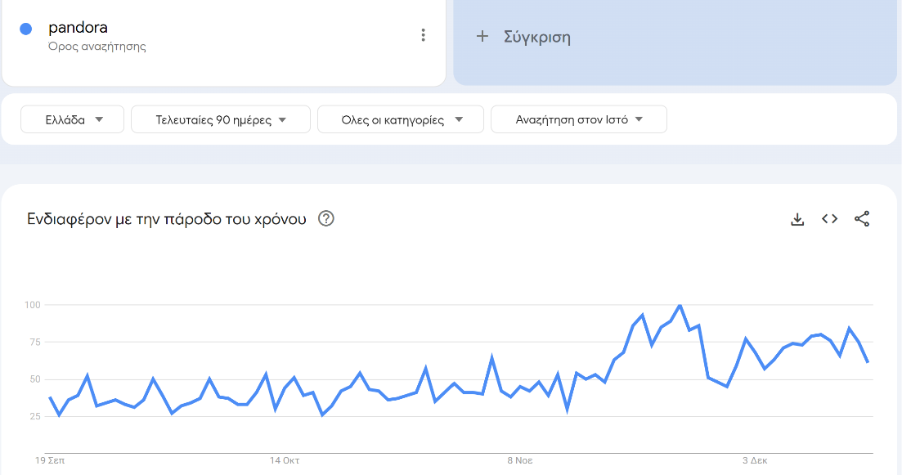
Figure 2- Google Trends- Pandora
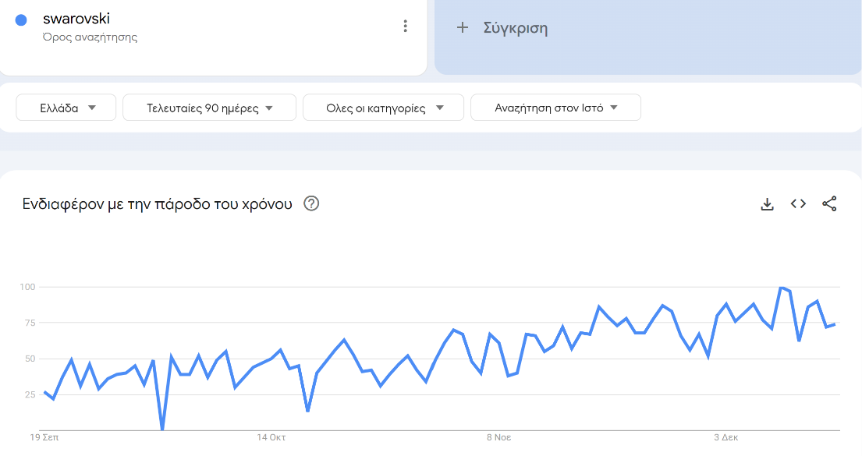
Figure 3- Google Trends- Swarovski
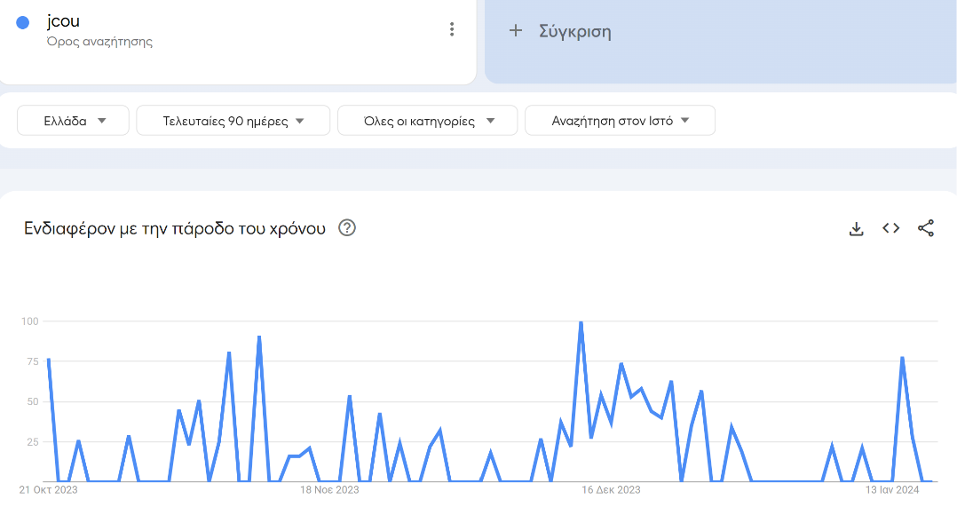
Figure 4- Google Trends- Jcou

- Keyword Research & Competitor Analysis
  - Keyword Research
A very important step of the process, before the creation of the website, was to identify the key terms and phrases our potential customers are actively searching for.
Our keyword strategy was anchored in utilizing the Google Ads Keyword Planner, a powerful tool that provides meaningful insights into search volumes, competition and trends.
Our primary focus was on selecting keywords that align with our product offerings, including earrings, rings, bracelets, necklaces, chains, and watches. We also considered modifiers such as "men's jewelry" and "women's jewelry" to tailor our approach to the diverse preferences of our target audience. Furthermore, we included long-tail keywords to capture more specific and niche search queries, allowing us to optimize our website's visibility. (Figures 5,6,7 and 8)
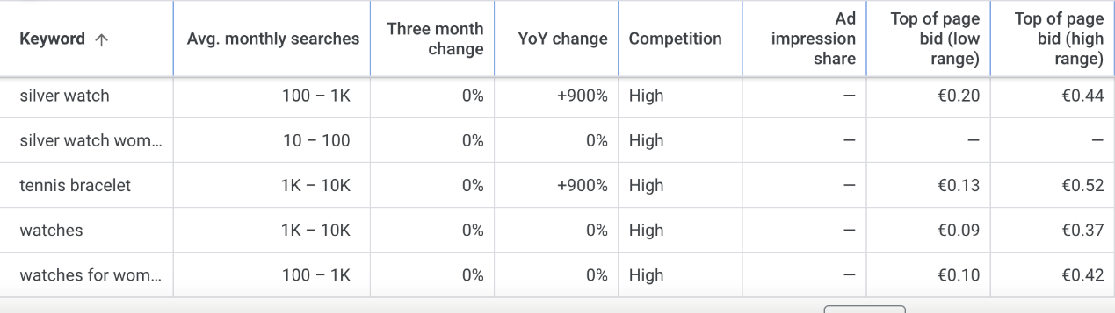
Figure 5
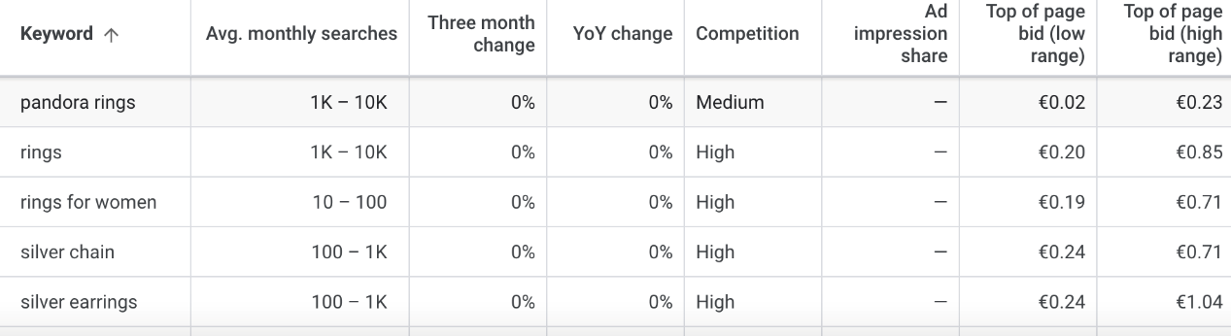
Figure 6
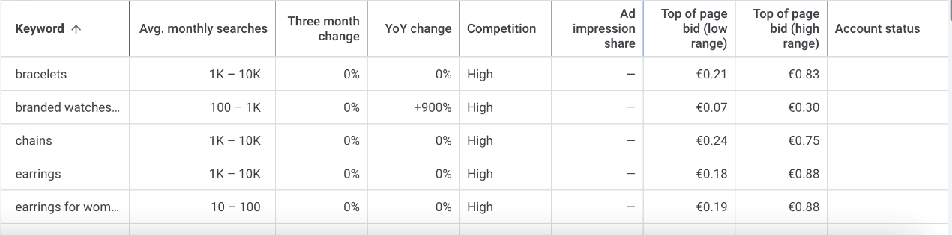
Figure 7
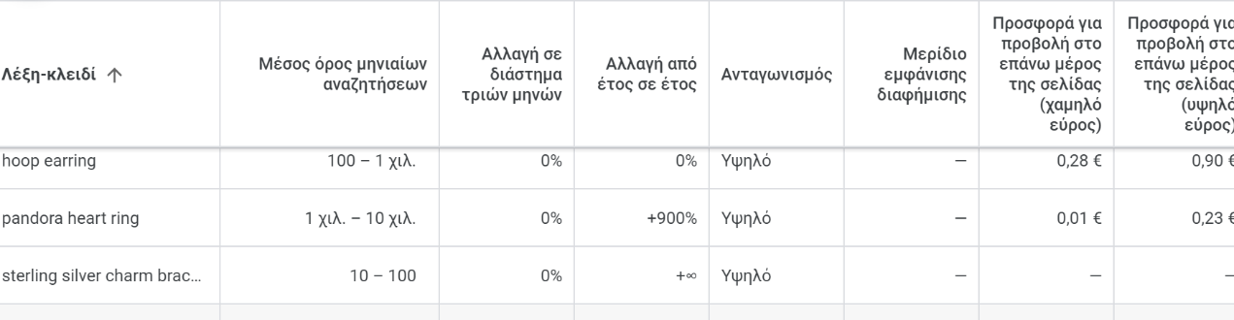
Figure 8
  - Competitor Analysis
To gain a first glimpse at the competitive landscape, we initially entered some of our top keywords, both plain and branded (such as pandora rings, watches for women, earrings, etc.) in the google search engine. We identified the websites that not only appeared higher in the organic and paid results, but also those that included more or less the same brands as we do. Such websites were the following: antwnakakis.gr, (Figure 9), athinajewellers.gr (Figure 10), e-dazz.gr (Figure 11), pandorashop.gr (Figure 12), acrystalworld.gr (Figure 13) and thebrandstore.gr (Figure 14).
To gain a more comprehensive insight into those competitors, we then used Semrush, a leading platform for competitor analysis. Semrush allowed us to dive deeper into the details of our top competitors in the jewelry e-commerce space. We analyzed their organic search strategies, identified their most successful keywords, and gained insights into their overall online presence. This information has been invaluable in shaping our SEO strategy to enhance Eclat's visibility in search engine results.

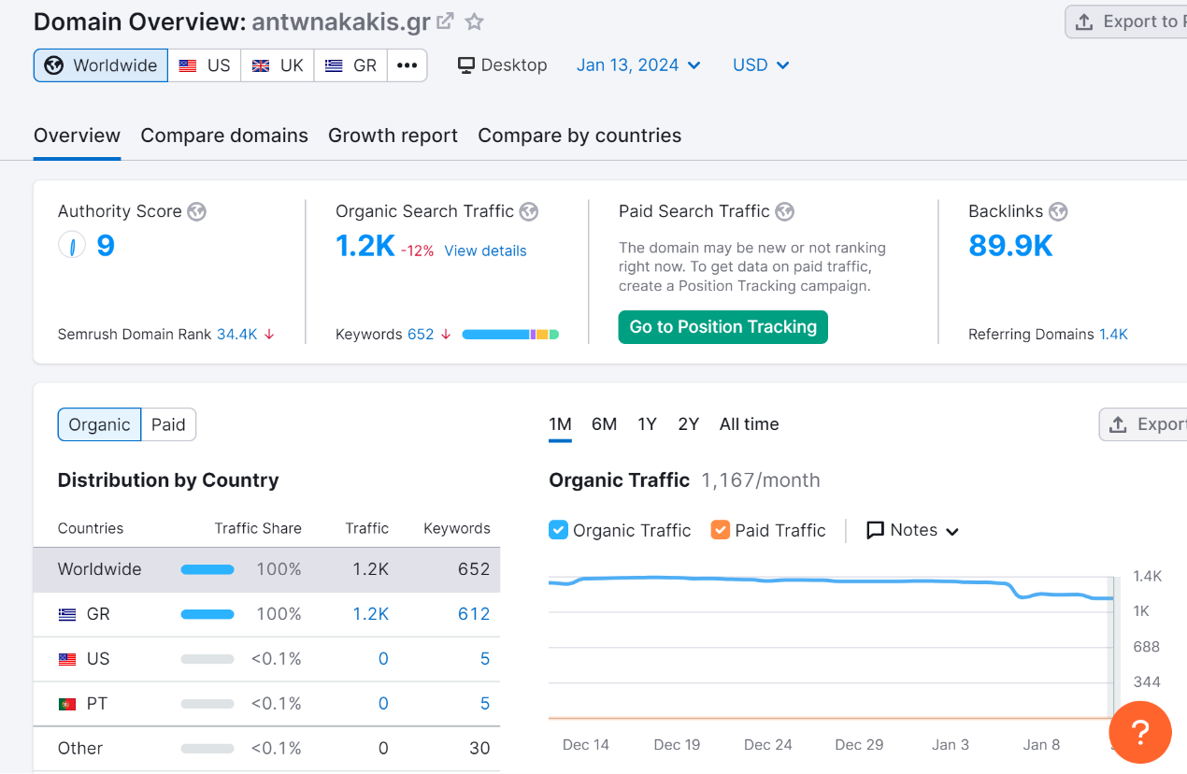
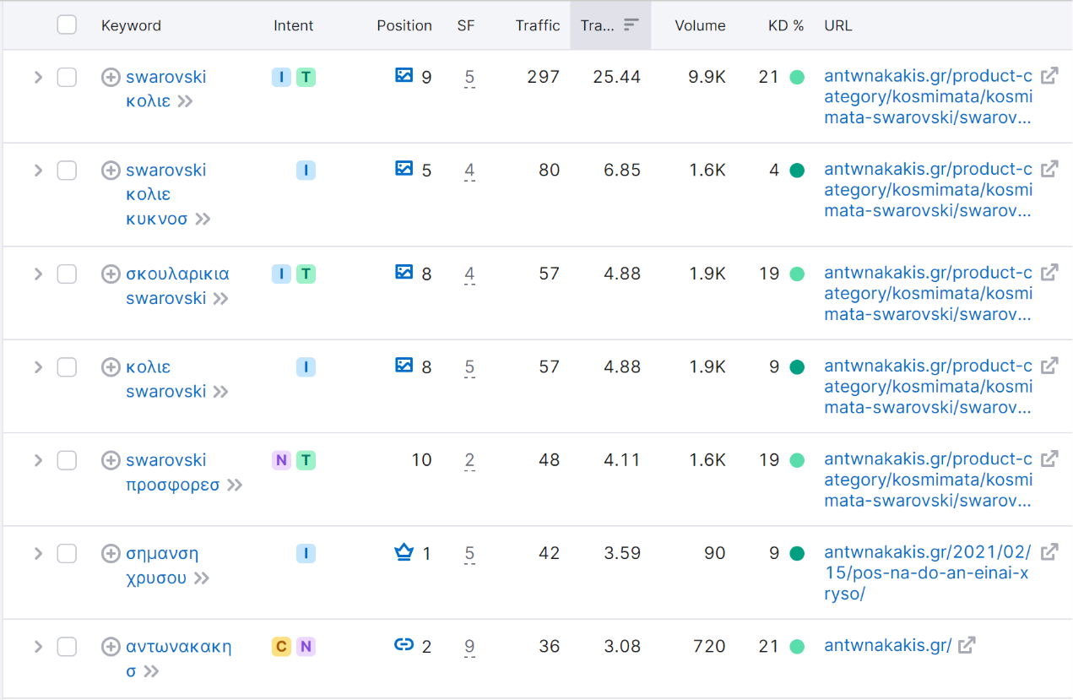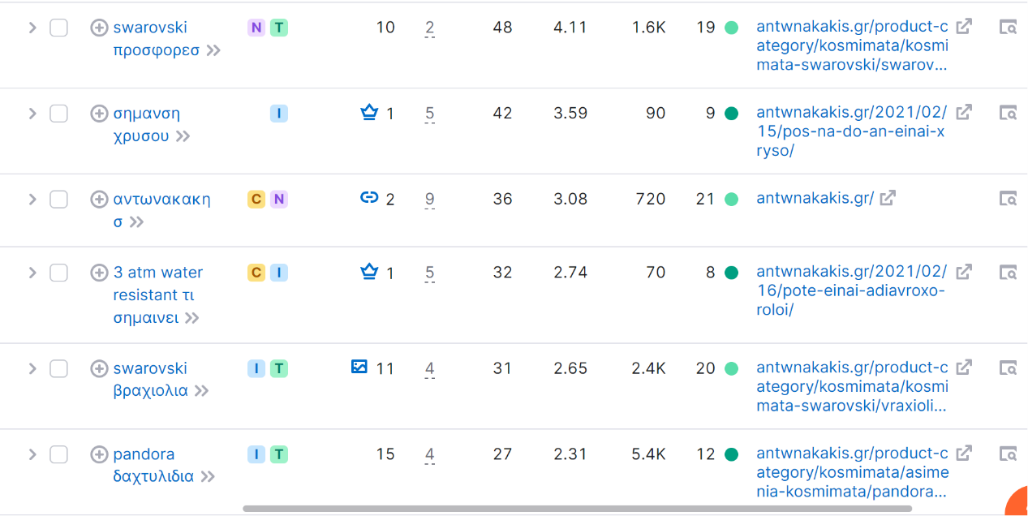
Figure 9- Semrush-Antwnakakis.gr
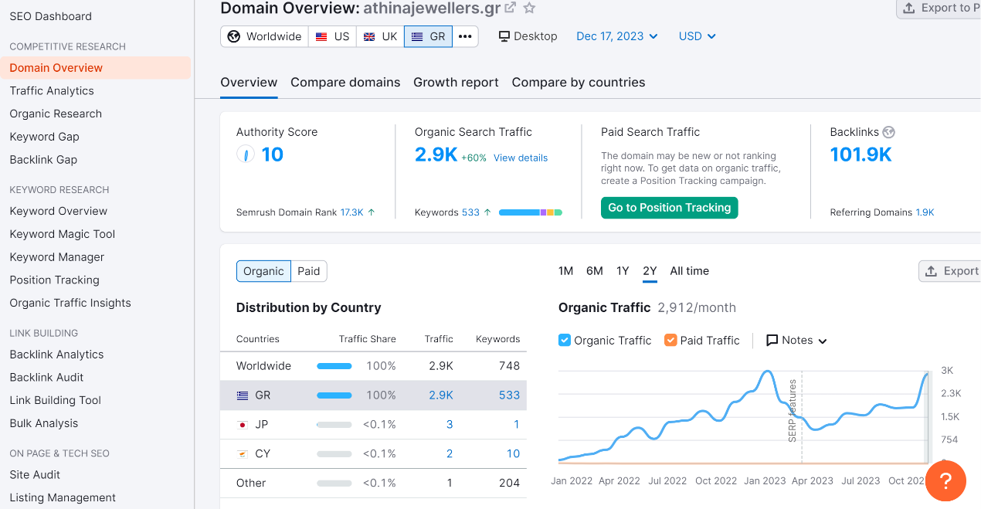
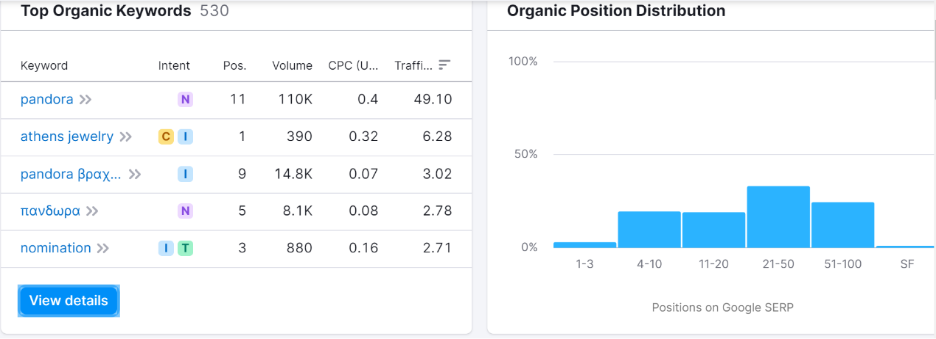
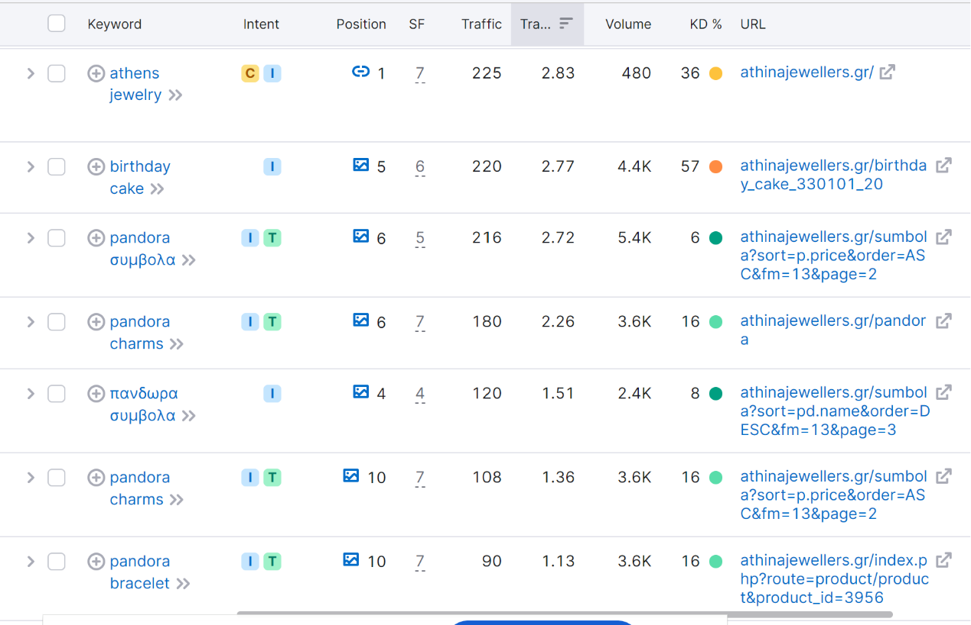
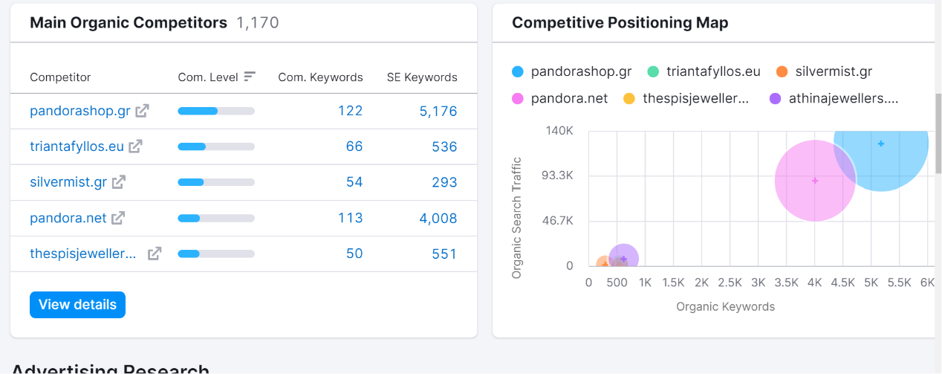
Figure 10- Semrush- athinajewellers.gr
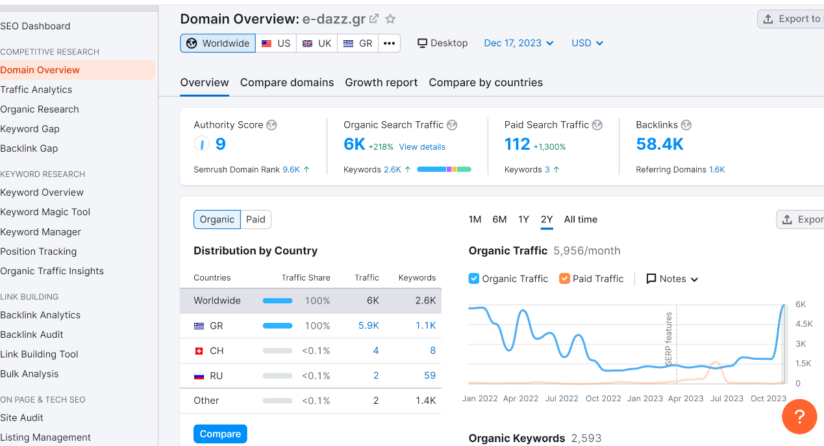
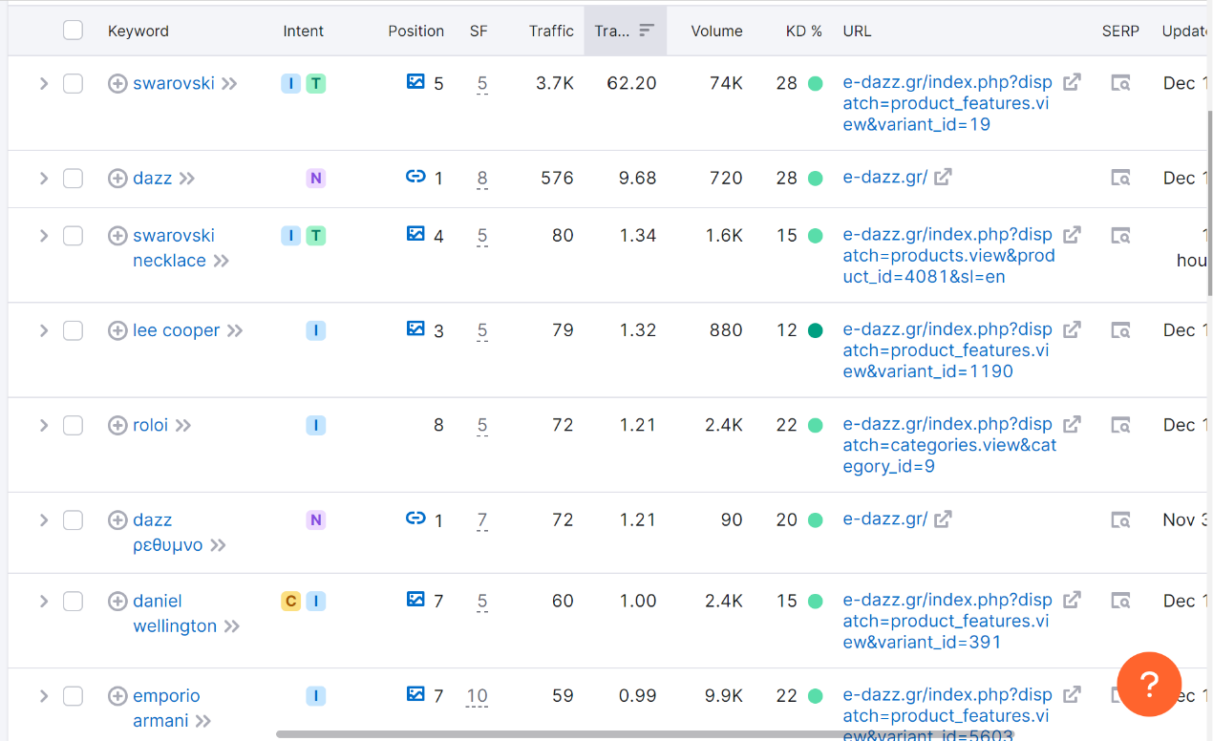
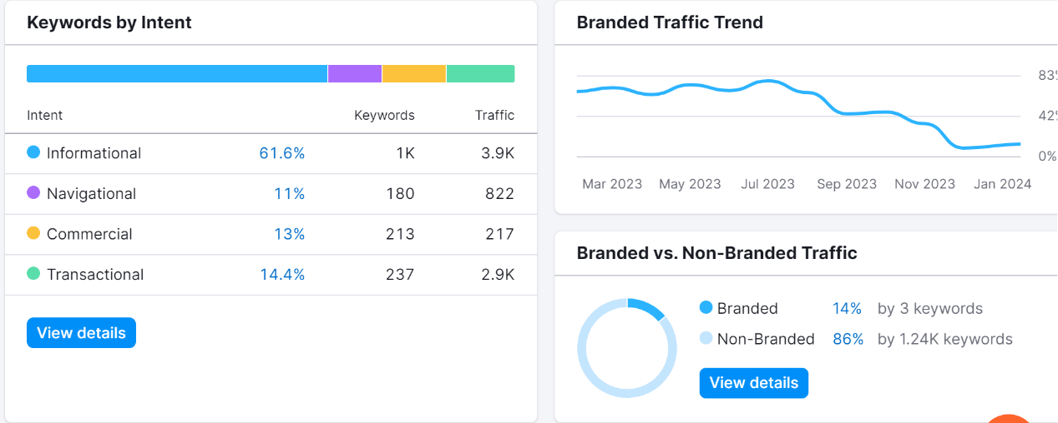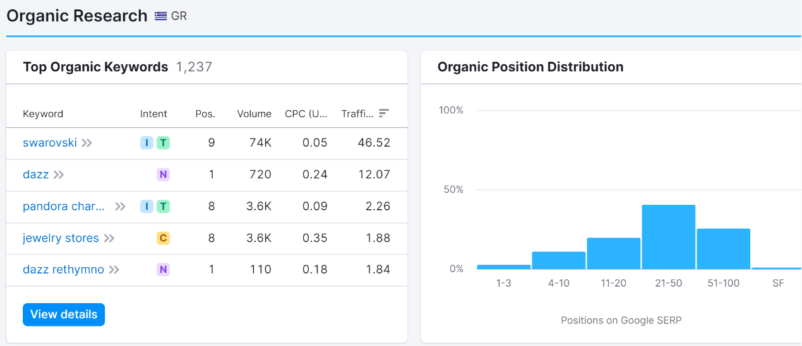
Figure 11- Semrush- e-dazz.gr

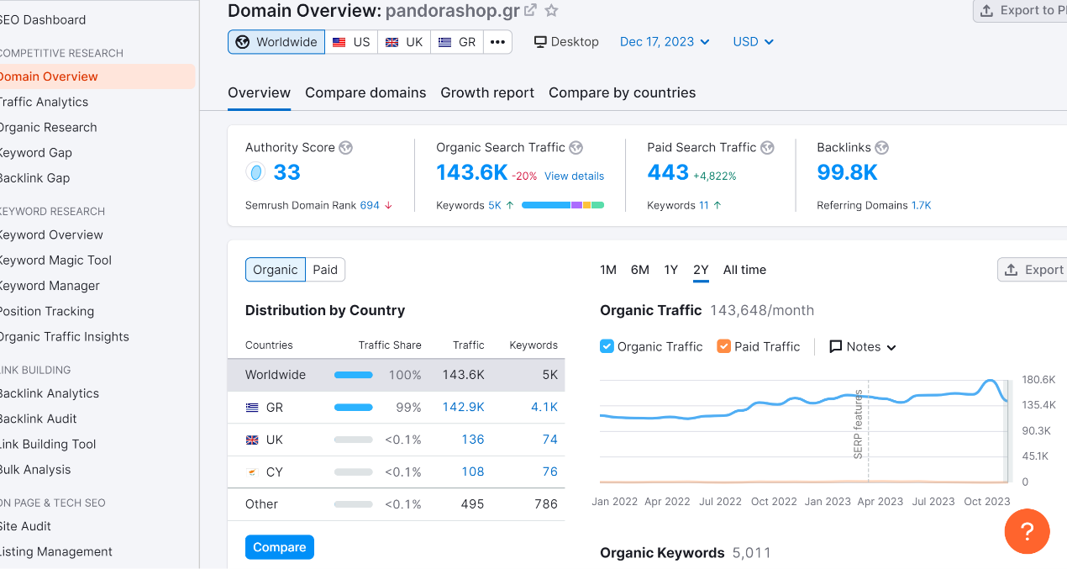
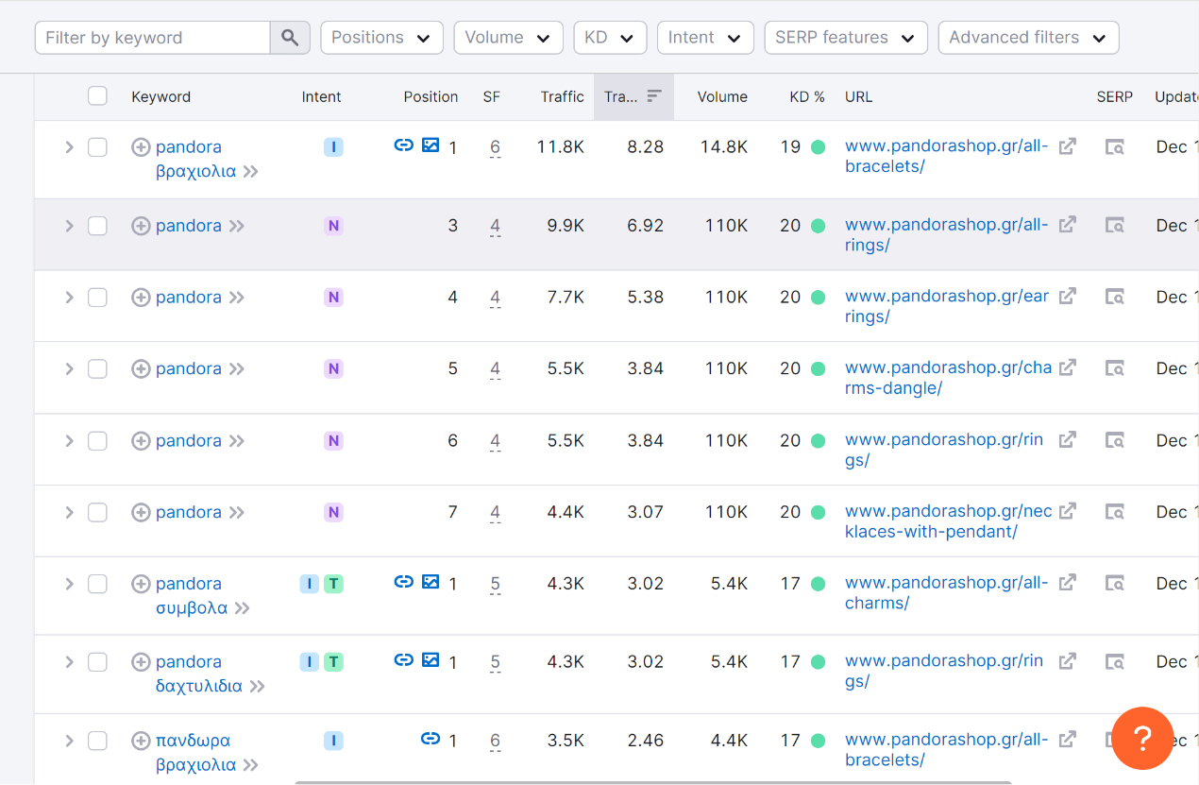
Figure 12- Semrush- pandorashop.gr
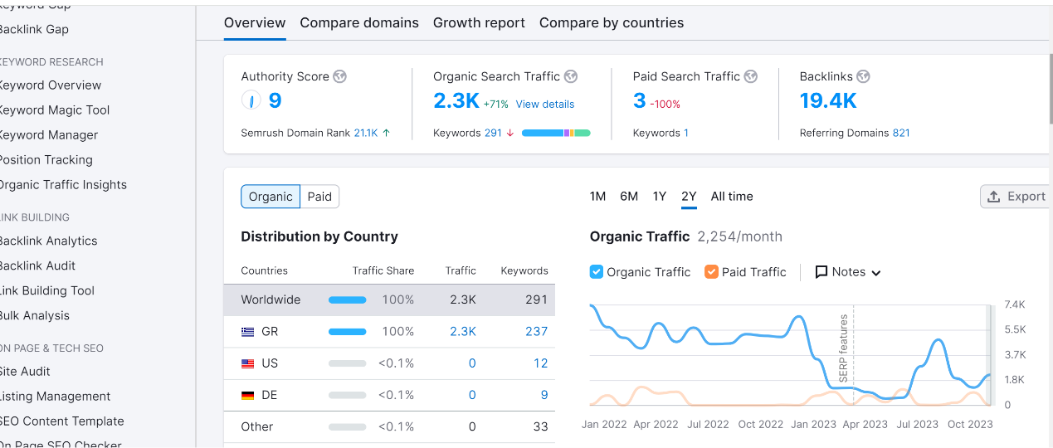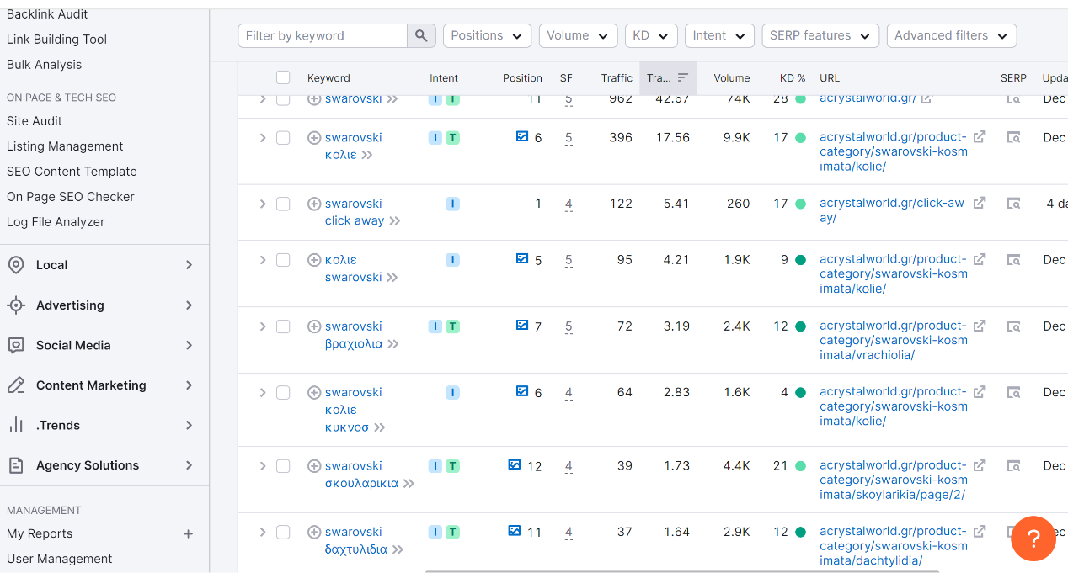
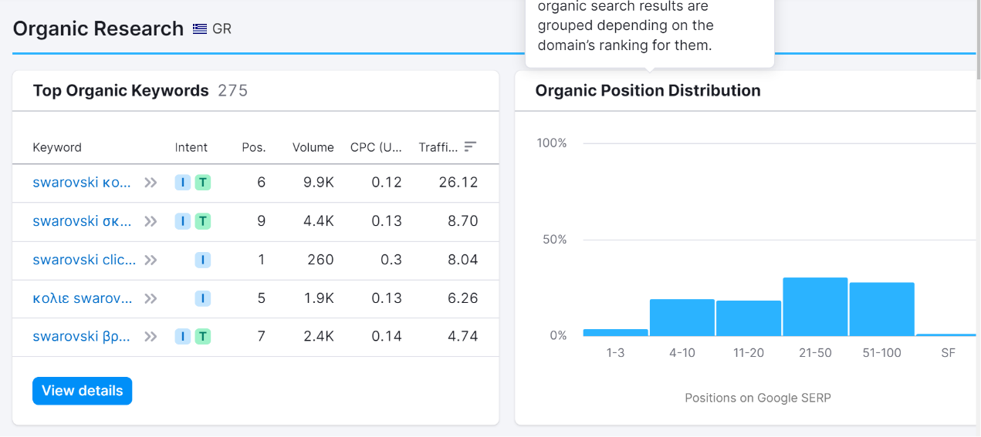
Figure 13- Semrush- acrystalworld.gr
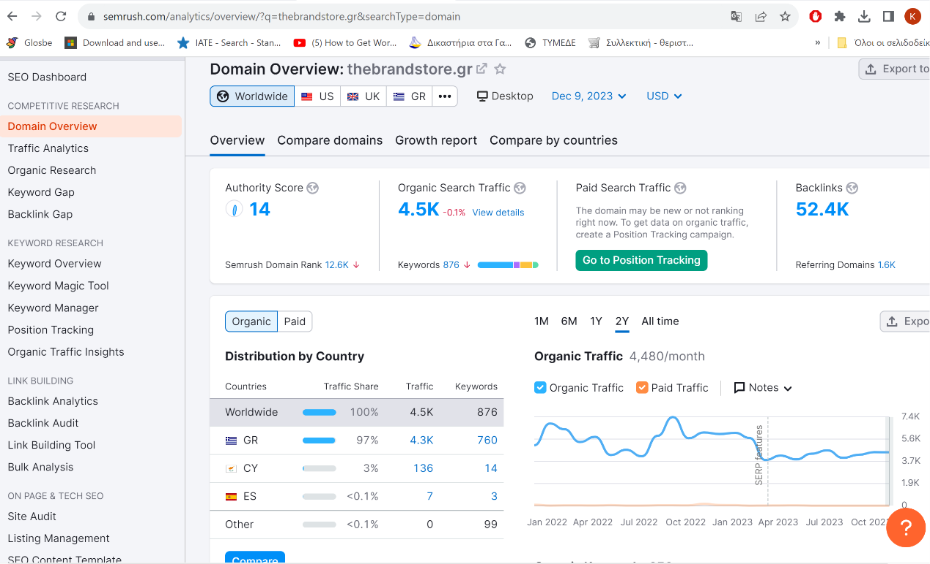
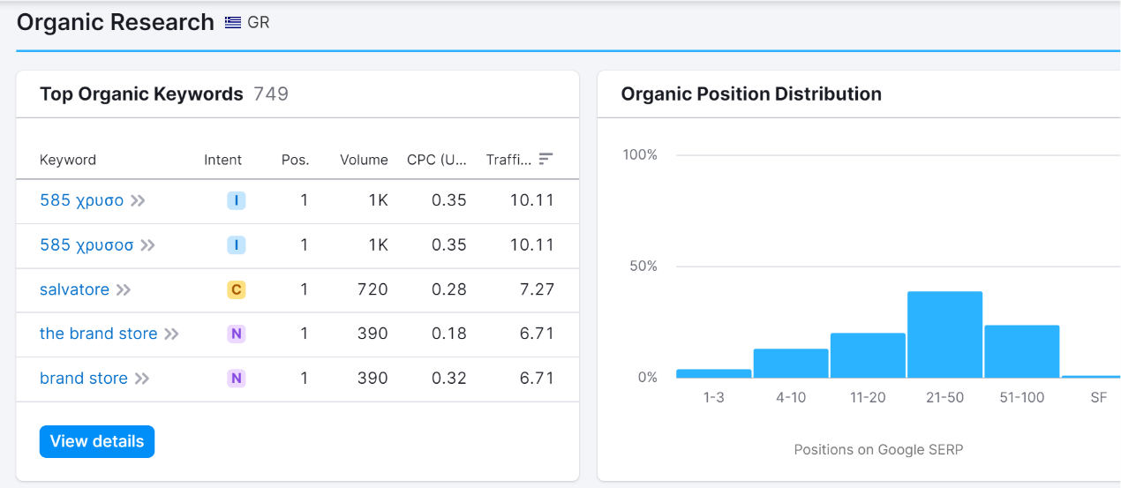
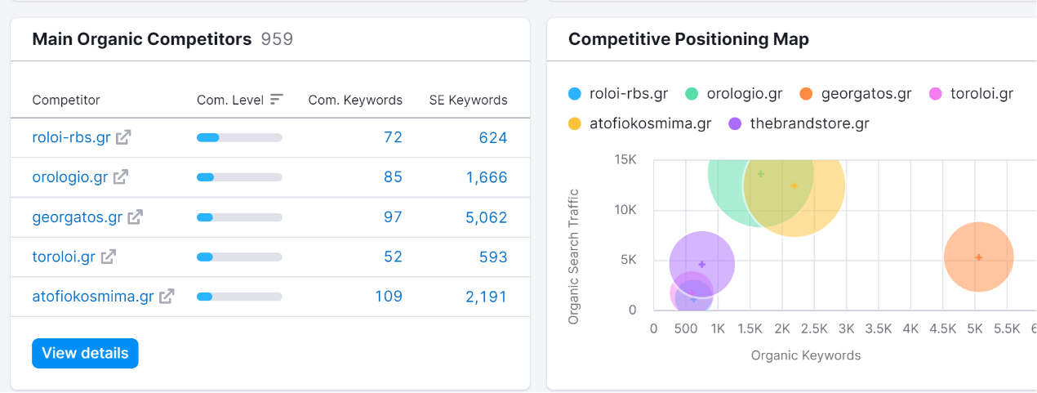
Figure 14- Semrush- thebrandstore.gr

With the insights gathered from both the keyword research and competitor analysis, we've developed a robust strategy to optimize Eclat's online presence. Our website content and metadata have been meticulously crafted to incorporate high-impact keywords identified through Google Ads Keyword Planner. Additionally, we have drawn inspiration from successful competitors to refine our approach to content creation, user experience, and digital marketing.
As we will later explain (in 4), following the building of the website, those insights have been greatly utilized for the optimization of our products, using the guidance of the YOAST plug-in.

- Building & Designing the Website
Eclat's digital presence was established using WordPress as our content management system. WordPress, renowned for its flexibility and user-friendly interface, provided us with a robust foundation for our e-commerce platform. To enhance the aesthetic and functionality of our site, we opted for the "Omega" theme—a versatile and customizable theme that aligns seamlessly with the elegance and sophistication of the Eclat brand.
Customizing our website, we put emphasis on creating an alluring and aesthetic homepage, incorporating soft colors, catchy phrases, a plethora of images as well as buttons for easy access to other pages within the website. (Figure 15 & link)
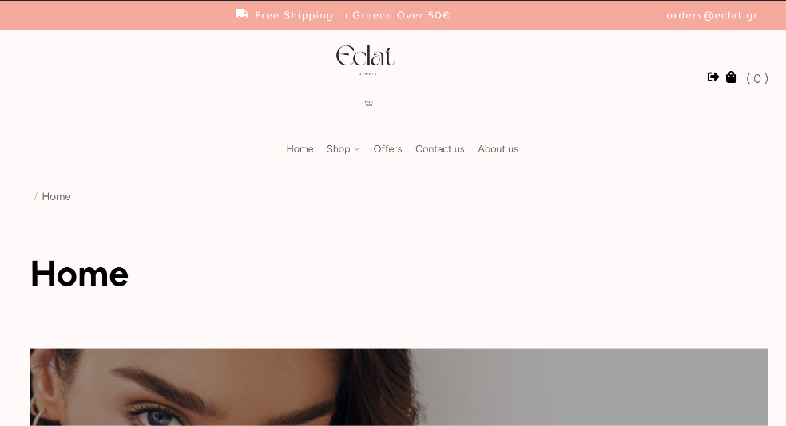

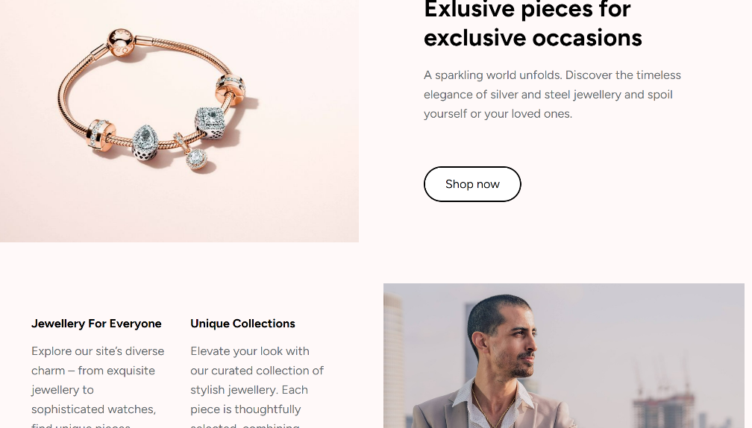
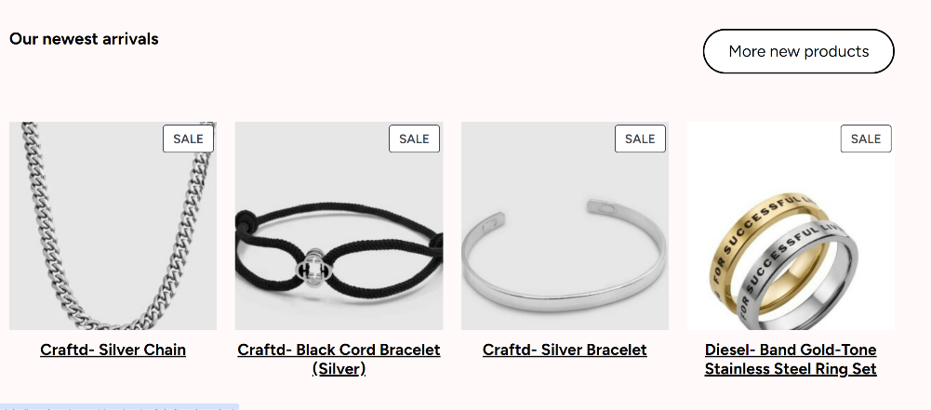
Figure 15- Eclat website homepage
Link to the website: https://dmlabs.ihu.edu.gr/group1/

Recognizing the critical role of SEO in driving organic traffic, we implemented the SEO silo theming strategy to structure our website content for maximum search engine visibility. More specifically, we initially created a diagram (Figure 16) organizing the content into silos (categories), with each silo focusing on a specific theme. We wanted to achieve a clear and user-friendly navigation and help visitors find relevant content. This is crucial for both visitors and search engine crawlers. In Figure 17, we can see how that was implemented on our e-commerce platform.
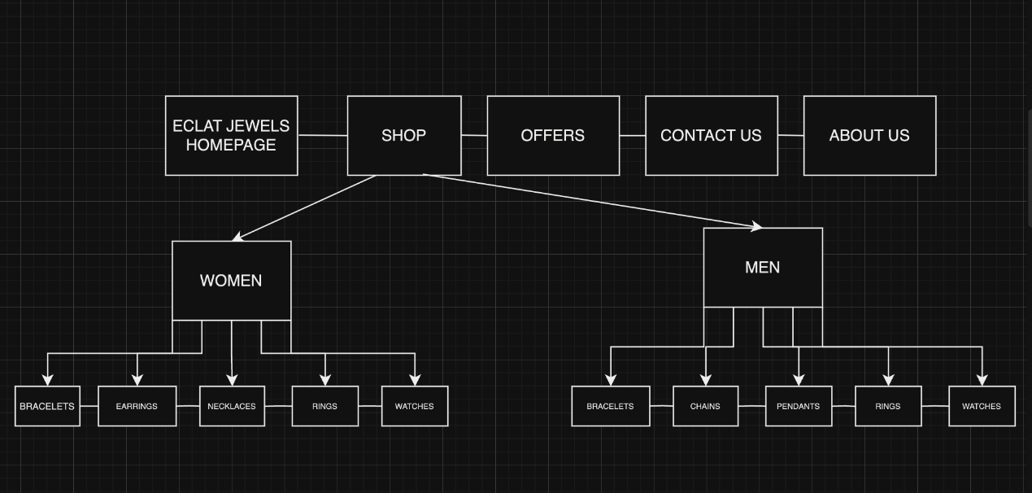
Figure 16- Silo structure diagram

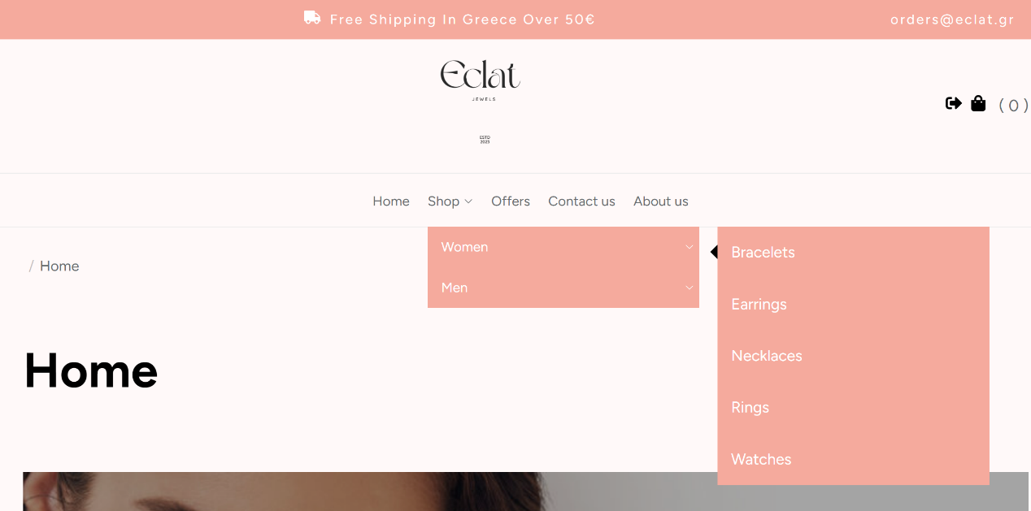
Figure 17- Silo structure

- SEO optimization of products
Using the keywords we analyzed above and the guidance of the YOAST plug-in, we then proceeded with the optimization of three product pages, selecting them based on the popularity of the brand. This selection process was highly influenced by the competitor analysis we had previously conducted, as we had gained an insight into the most popular brands for our competitors. The three product pages were the following: Pandora Ring With Heart-shaped Cubic Zirconia (Figure 18), Sparkling Oxette Hoop Earrings With Purple Zirconia Details (Figure 19) and Michael Kors- Parker Pavé Gold-Tone Leather Watch (Figure 20).
We started by entering our relevant keyword each time in the Yoast SEO plug-in. We then used the keyphrase to create product titles with the appropriate length as well as a meta-descriptions and slugs, making sure that our selected keyphrases were used.
We then followed the recommendations of YOAST SEO and ensured that the text length was around 300 words, the keyphrases were included in the introductions and were used in the proper amount throughout the text, we incorporated internal links (that led to other pages within our sites, e.g. the ring product pages) as well as outbound links, that led to posts such as ring size guides, how to clean your watches, etc.
We, also, ensured that our content was readable, and that we used enough active voice in the texts, the paragraph and sentence length were appropriate, as well as there were enough transition words for our content to be easily read and understood by our customers.
Last but not least, we ensured that we used our keyphrase in the alt text, the title and the description of the product images.
All these steps lead towards a good SEO and Readability score.
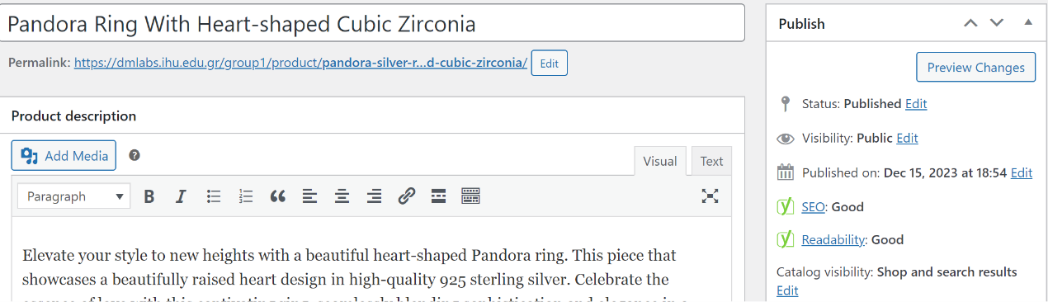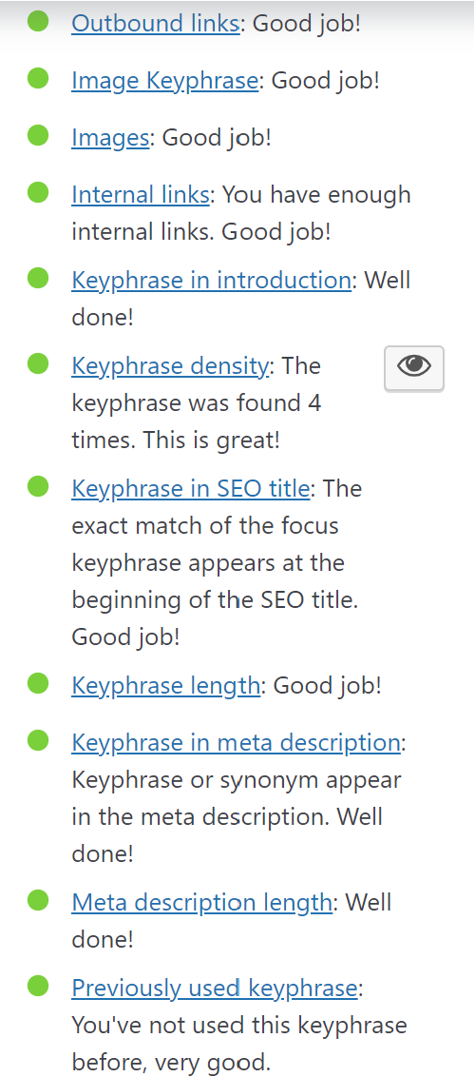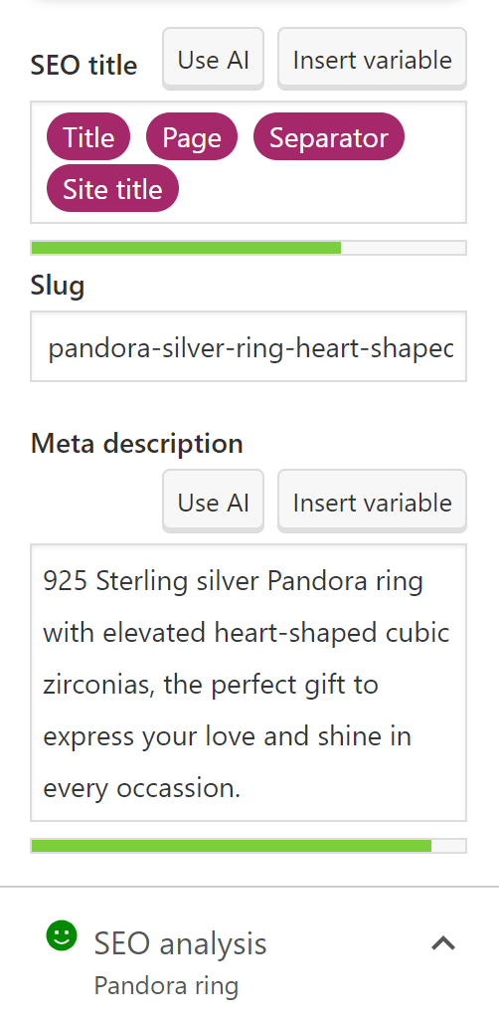
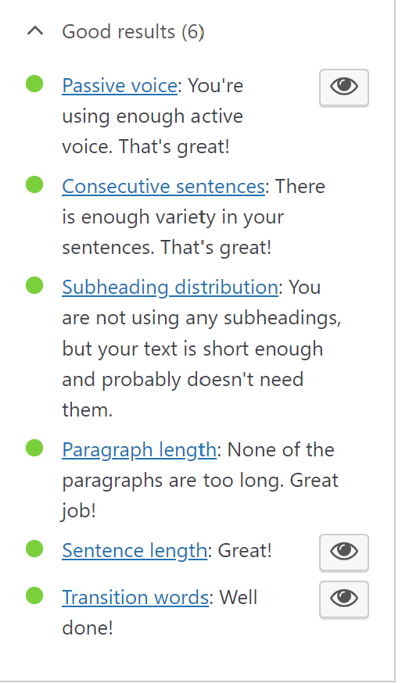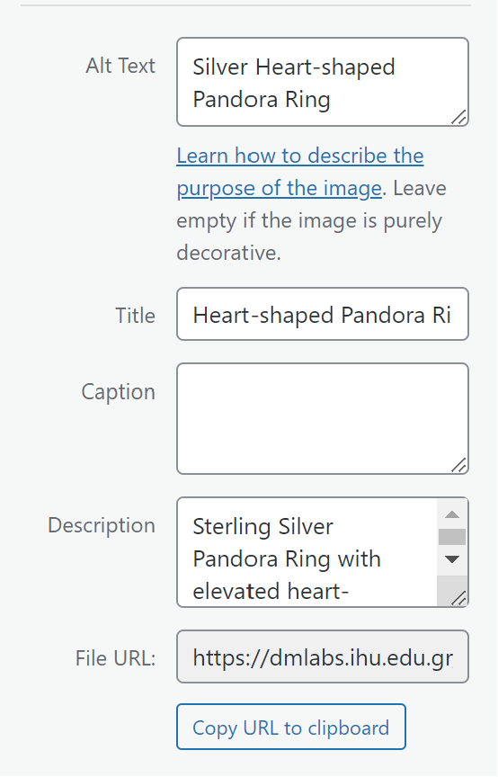
Figure 18- YOAST SEO- pandora ring- keyphrase: pandora ring

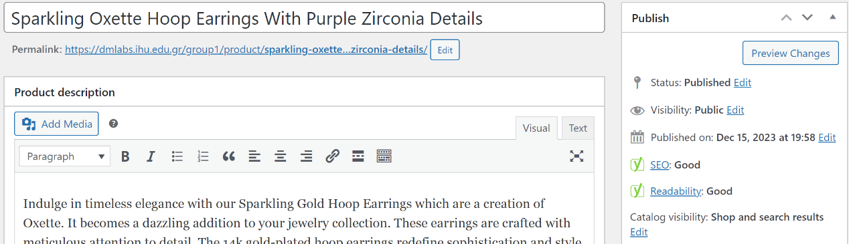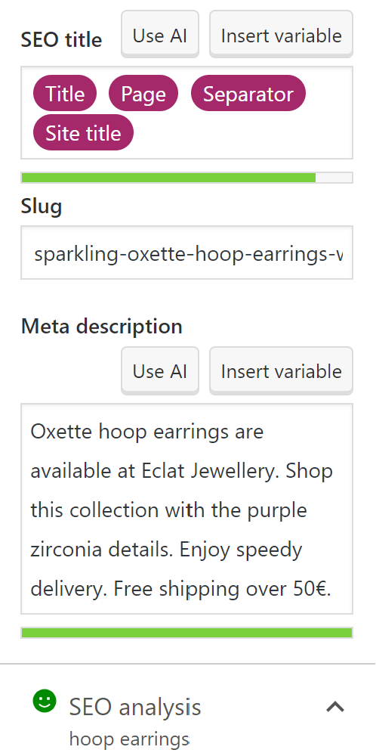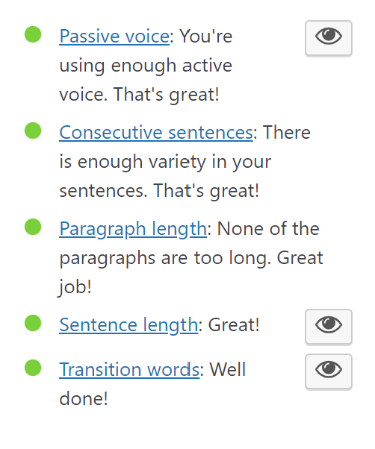
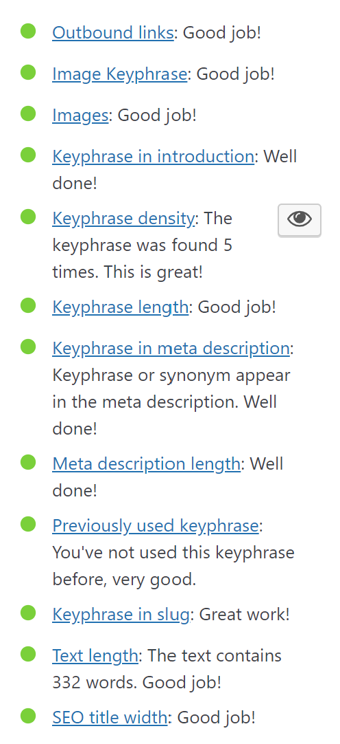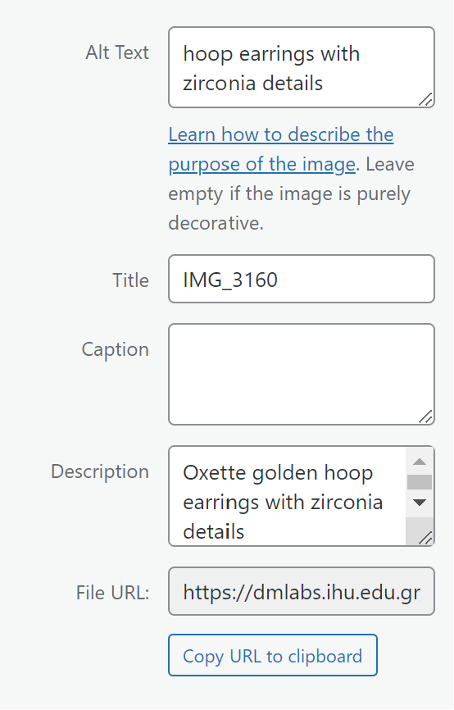
Figure 19- YOAST SEO- oxette hoop earrings: keyphrase: hoop earrings
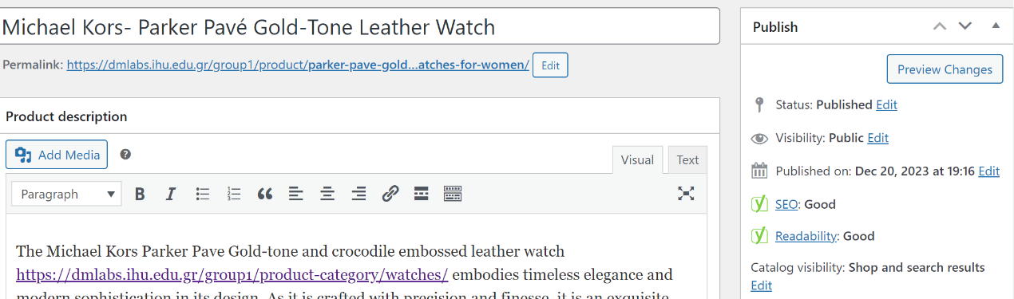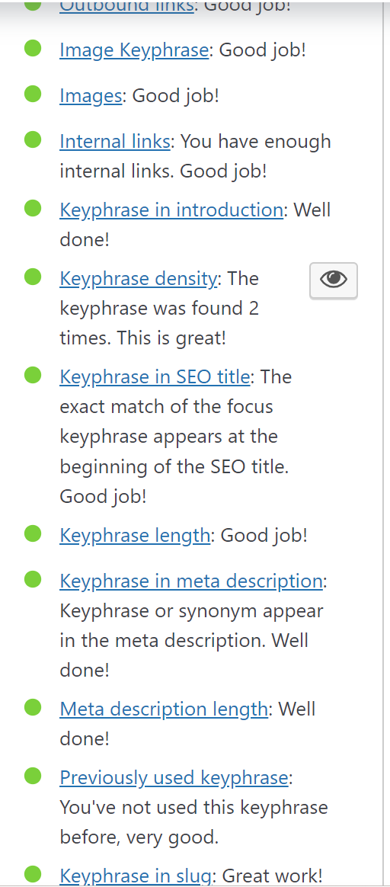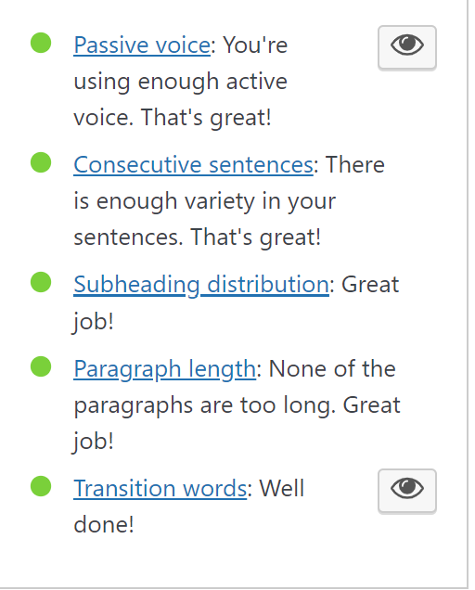
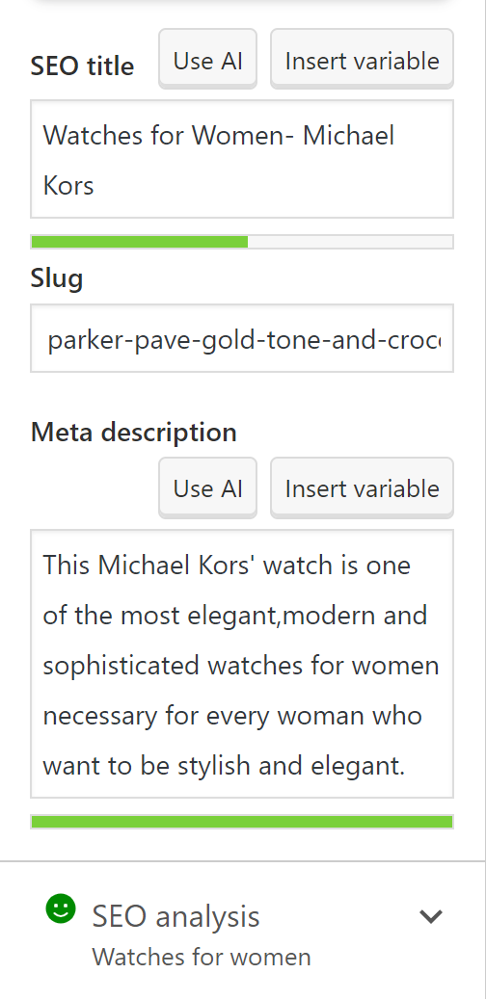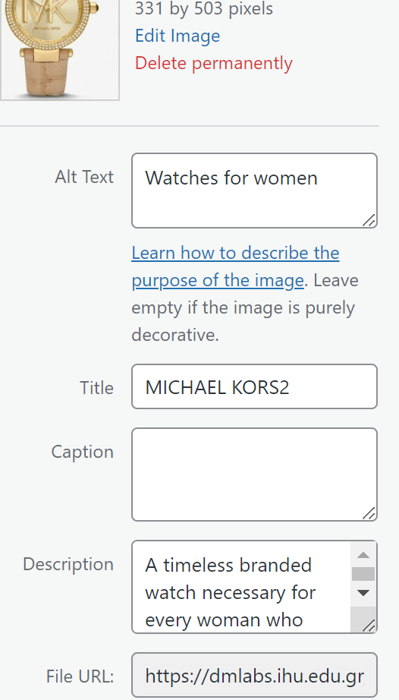
Figure 20- YOAST SEO- Michael Kors- keyphrase: watches for women

PART C
1-2. PPC campaigns have become an important part of online marketing strategies. Those strategies give a chance to every business in order to reach and increase their audience, drive traffic and achieve marketing objectives in a cost-effective manner. In order to complete the PPC Ads part we found firstly the brand and the products that we wanted to promote in our campaign. The main selection criterion was which products have the most sales and appeal. Every successful PPC campaign starts with keyword research. We used the tool of “Google Ads Keyword Planner” and as you can see rings have a lot of searches. The goal was the understanding of user intent, competitiveness, and the potential for conversions.
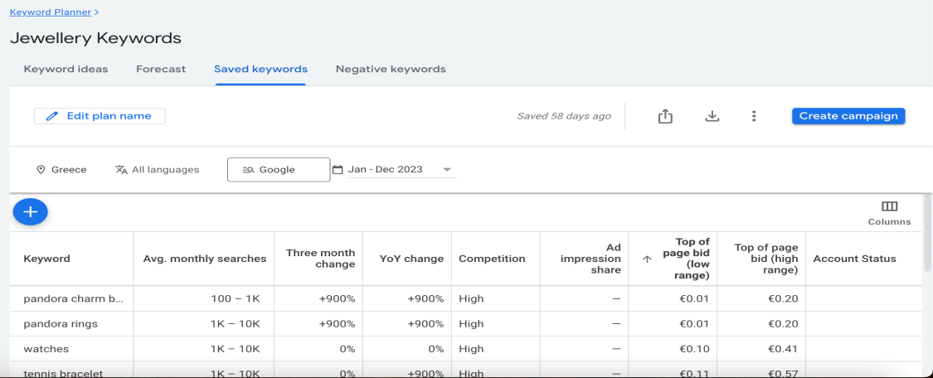
Figure 21- .keyword research
3. As it concerns the keyword research is vital for the PPC campaigns. Effective keyword selection ensures that ads are shown to the right audience. We used the Google Ads Keyword Planner for keyword suggestions and search volumes. Rings are famous and have high search volume so the search campaign was based on them. Selecting high quality, relevant keywords for our advertising campaign helped us to reach the customers we wanted.
4. We used the tool of Google trends to identify which brands are more popular and have a strong online presence from our website and we found out that Pandora have high searches and then Swarovski. The whole campaign was based on them. Both brands have a strong online presence, making them viable options for a high-search website campaign.

. 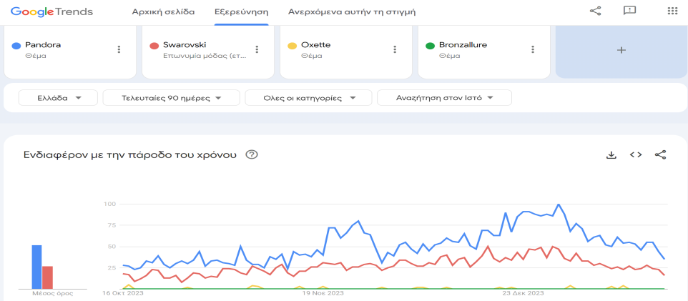
Figure 21- .Google trends diagram

We created one Search campaign for sales with two Ad Groups. The products that we decided to include in our campaign were the “The Pandora Ring with Heart-Shaped Cubic zirconia” (1st ad group) and the “Swarovski trilogy ring” (2nd as group).

Pandora
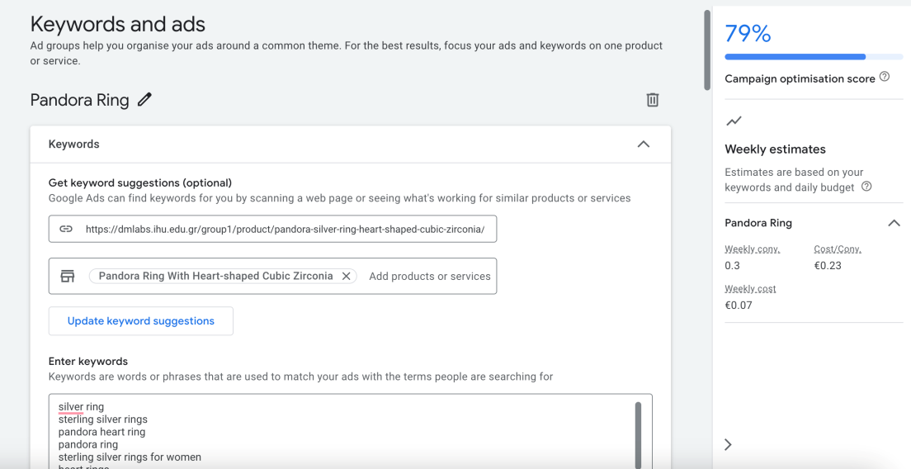
Figure 22-pandora keywords and ads
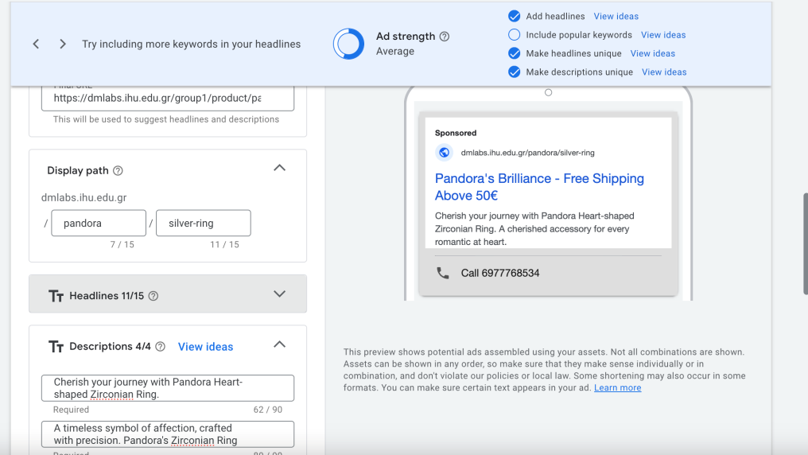
Figure 23- display path and descriptions
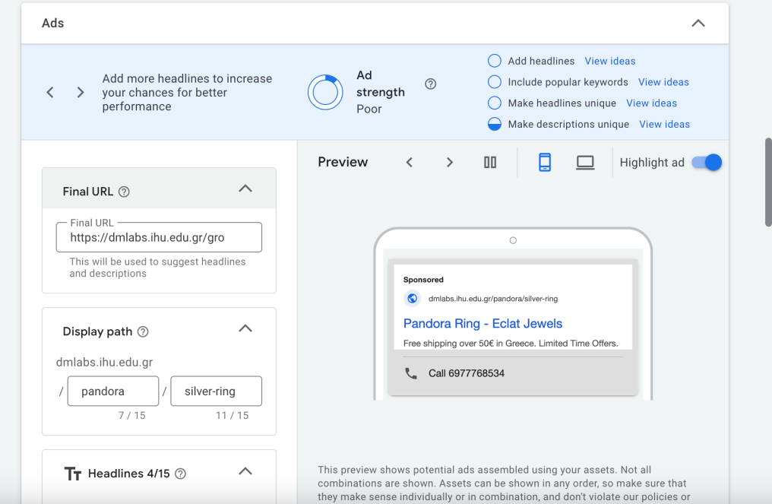
Figure 23- .pandora preview
Swarovski
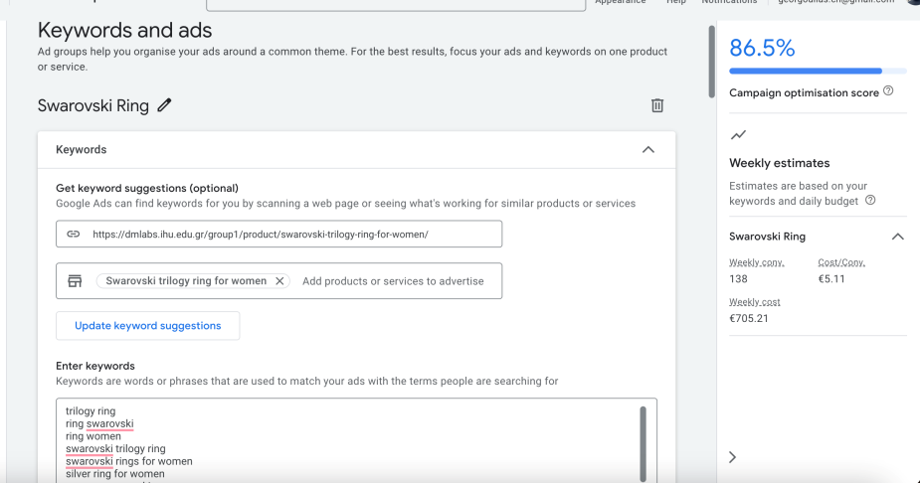
Figure 24- swarovski keywords and ads

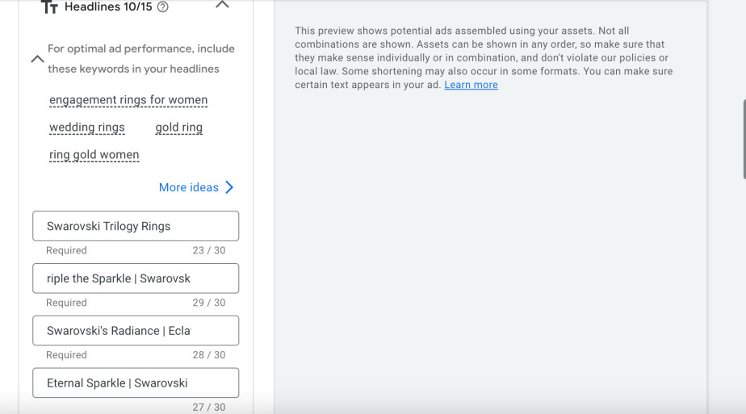
Figure 25- headlines

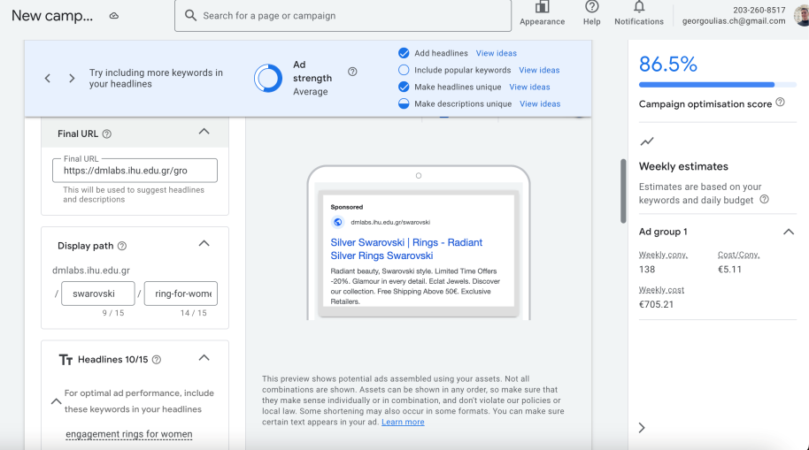
Fugure 26-swarovski preview
PCC campaigns are not limited to a single platform but we decided to use Google Ads platform which is one of the most popular. We completed all the steps. First we insert the URL of each product and the product itself. Then, we entered the appropriate keywords, attractive headlines, descriptions, the name of the brand and the display path. For the keywords, we used related keywords to each product. We found some ideas from the suggested ones for example for the “Pandora ring” we used keywords such as silver ring, sterling silver ring, Pandora heart ring, sterling silver rings for women. For the “Swarovski ring” we used keywords such as trilogy ring, ring Swarovski, Swarovski ring for women, Swarovski trilogy ring.
5. Concerning Display campaigns the users may not have looked directly for the product but they could be interested for the displayed content. We created a Display Network campaign for one of our most popular product which is the “Pandora bracelet sterling silver with tree of life”. We followed the same procedure as with the Search campaign. Firstly, we completed the campaign settings, we set a budget and the target audience (age and location).We created the ad by adding the image of the product, descriptions and headlines. We tried to insert as much keywords as possible in the descriptions and headlines. We made them attractive and we also used the name of the brand “ECLAT” many times. In the end we saw the final result (preview).
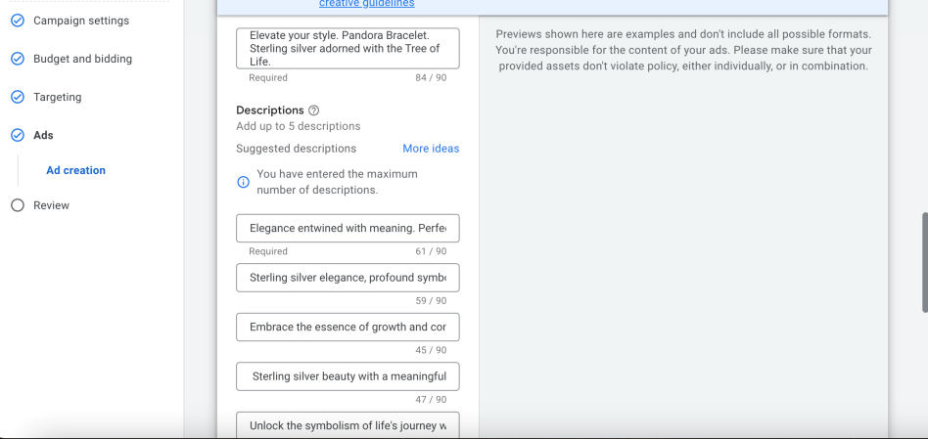
Figure 27-display descriptions
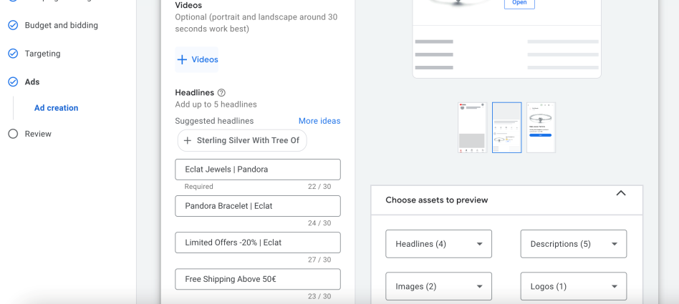
Figure 28-display headlines
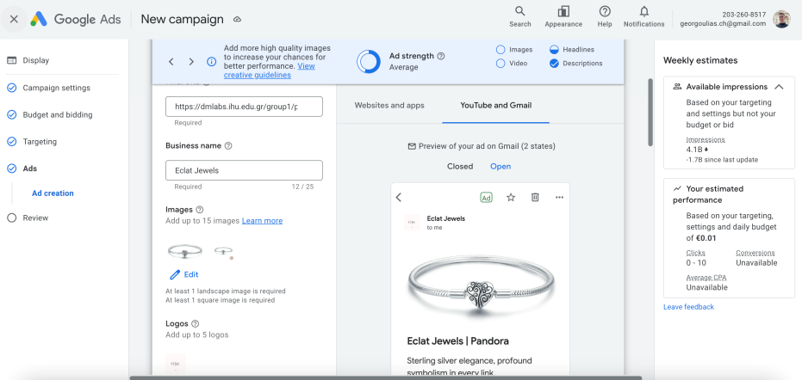
Figure 29- display preview

In many cases, a digital marketing strategy may include both Search and Display campaigns in order to address different stages of the costumer journey. A well-executed PPC campaign strategy involves continuous monitoring, adaptation, and performance data.
6. The PPC strategy plan that we followed:
- Define our goal: identify the objectives such as boost brand awareness, increase sales and website traffic.
- Understand the target audience: analyze demographics, online behavior and interests. The information helped us in order to find the appropriate keyword selection.
- Keyword research: we used Google Keyword Planner to identify relevant search terms align with our jewelry e-shop. The tool helped us with keywords of a good balance of search volumes.
- Competitor analysis: we have analyzed our competitors’ strategies in order to find weaknesses and opportunities.
- Budget allocation: we have set a realistic budget for our campaign. The budget was allocated based on the importance of different campaigns, the products that we wanted to promote and the overall goals.
- Campaign structure: we organized the campaign and the ad groups and then we ensure that it was easy to optimize.
- Ad creation: we highlighted the selling points, wrote down the headlines and the descriptions and the call to actions to encourage clicks.
- Landing page optimization: we found out that our landing pages linked to our ads are user-friendly and optimized for more conversions.
- Use analytics: we used Google Analytics to monitor our campaign performance.
- A/B Testing: we wanted to improve our campaign’s performance so we did some research and test different elements to see which one suits better to our audience.
- Adapt to trends: we organized and adjusted our campaign accordingly based on industry trends. This is a procedure that needs to be updated often.
- Performance reporting: In the end we wrote some performance reports to identify if the PPC campaigns were successful or not and make some decisions for future campaigns.

